PROFIBUS-DP
XB6 Series Slice I/O
User Manual

Nanjing Solidot Electronic Technology Co., Ltd

Copyright © 2023 Nanjing Solidot Electronic Technology Co., Ltd. All rights reserved.
Without written permission of our company, no organization or individual may extract, copy or transmit part or all of this document.

Trademark Notice
and other Solidot trademarks are all trademarks of Nanjing Solidot Electronic Technology Co., Ltd.
All other trademarks or registered trademarks referred to in this document belong to their respective owners.

Note
The products, services or features you purchase shall be subject to the commercial contracts and terms of Solidot.
All or part of the products, services or features given in this document may not be within the scope of your purchase
or use. Unless otherwise agreed in the contracts, Solidot does not make any express or implied statement or warranty for the content of this document.
Due to product version upgrading or other reasons, the content of this document is subject to changes from time to
time. Unless otherwise agreed, this document shall be only used as reference. None of the statements, information
and suggestions in this document shall constitute any express or implied warranty.

Nanjing Solidot Electronic Technology Co., Ltd.
Address: Angying Building, No. 91 Shengli Road, Jiangning Zone, Nanjing, Jiangsu
Postal code: 211106
Telephone: 4007788929
Website: https://www.solidotech.com/en

Table of Contents

1 Product Overview 1
1.1 Product Introduction 1
1.2 Product Feature 1
1.3 Application Configuration 2
2 Designation rules 3
2.1 Designation rules 3
2.1.1 Coupler Designation Rules 3
2.1.2 I/O Module Designation Rules 4
2.2 List of common modules 5
3 Product Parameters 6
3.1 General Parameters 6
3.2 Power parameters 6
3.3 Interface Parameters 7
3.4 Digital parameters 7
3.5 Analog parameters 8
3.5.1 Technical parameters 8
3.5.2 Voltage I/O Range Selection and Code Value Table 9
3.5.3 Current I/O Range Selection and Code Value Table 11
3.6 Common terminal expansion module parameters 12
4 Panel 14
4.1 Coupler Panel 13
4.1.1 Coupler Structure 13
4.1.2 Rotary Switch 14
4.1.3 Indicator Function 16
4.2 I/O Module Panel 17
5 Installation and Disassembly 18
5.1 Installation Instructions 18
5.2 Installation and Disassembly Steps 19
5.3 Installation Schematic Diagrams 20
5.4 Dimension 24
6 Wiring 27
6.1 Wiring Terminal 27
6.2 Wiring Instructions and Requirements 27
6.3 I/O Module Wiring Diagrams 34
6.3.1 XB6-3200A 34
6.3.2 XB6-3200B 35
6.3.3 XB6-1616A 36
6.3.4 XB6-1616B 37
6.3.5 XB6-1600A 38
6.3.6 XB6-1600B 39
6.3.7 XB6-0800A 40
6.3.8 XB6-0800B 41
6.3.9 XB6-0032A 42
6.3.10 XB6-0032B 43
6.3.11 XB6-0016A 44
6.3.12 XB6-0016B 45
6.3.13 XB6-0008A 46
6.3.14 XB6-0008B 47
6.3.15 XB6-0012J 48
6.3.16 XB6-A80V 49
6.3.17 XB6-A80I 50
6.3.18 XB6-A40V 52
6.3.19 XB6-A40I 53
6.3.20 XB6-A08V 54
6.3.21 XB6-A08I 55
6.3.22 XB6-A04V 56
6.3.23 XB6-A04I 57
6.3.24 XB6-A80TM 58
6.3.25 XB6-A40TM 59
6.4 Common Terminal Expansion Module Wiring Diagrams 60
7 Operation 61
7.1 Module Application 61
7.2 Module Parameter Configuration Function 62
7.2.1 Digital Input Filtering 62
7.2.2 Analog Filtering Configuration Function 62
7.2.3 Analog Range Selection 63
7.3 Bus Module Configuration Description 64
7.3.1 Application in the TIA Portal V17 software environment 64

Product Overview

Product Introduction
XB6 series slice I/O modules feature a combination of couplers and I/O modules. The couplers connect
extendable I/O modules to a real-time industrial control system. The I/O modules communication
backplane is equipped with X-bus to provide high real-time performance and connects a variety of modules.
It helps users collect high-speed data, optimize system configuration, simplify field wiring, and improve
system reliability.

Product Feature
- Fewer nodes occupied
A node consists of a bus coupler, 1 to 32 X-bus series I/O modules, and an end cover.
- Diverse functional expansion options
- Flexible expansion is supported, and a complete range of IO types are provided. It is possible to integrate digital, analog, temperature, pulse and other modules to meet different application needs.
- Flexible configuration
Multiple types of slice I/O modules are offered for free combination.
- High compatibility
The coupler communication interface conforms to communication standards and supports mainstream PROFIBUS-DP master stations.
- Transmission Rate Adaptive
Transmission rate support range 9.6 Kbps ~ 12 Mbps.
- Small footprint
Compact structure and small footprint.
- Easy diagnosis
An innovative channel indicator design is adopted. As the indicators are placed close to the channels, channel status is displayed intuitively and clearly, facilitating detection and maintenance.
- Quick
The backplane utilizes the X-bus: scanning period max. 1 ms.
- Easy installation
Installation on standard DIN 35 mm rails.
Spring terminal blocks are used for convenient and fast wiring.

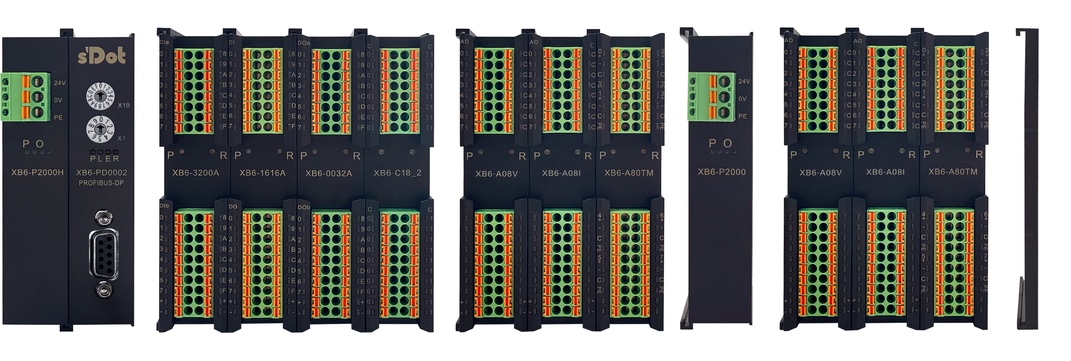
Application Configuration

I/O Modules
Function Module
coupler module
Extensions
power module
End cover
I/O Modules
Function module

Application method:
Different modules can be combined, including power supply, coupler, digital, analog, relay, temperature, and other modules.
Application Configuration:
Different I/O module combinations can be adopted depending on master station access capacity, number of stations, I/O points, function type, and other requirements.
Configuration rules:
From left to right, the modules should be arranged in the order of power supply, coupler module, I/O modules, and cover plate (must be configured).

Designation rules

Designation Rules

Coupler Designation Rules
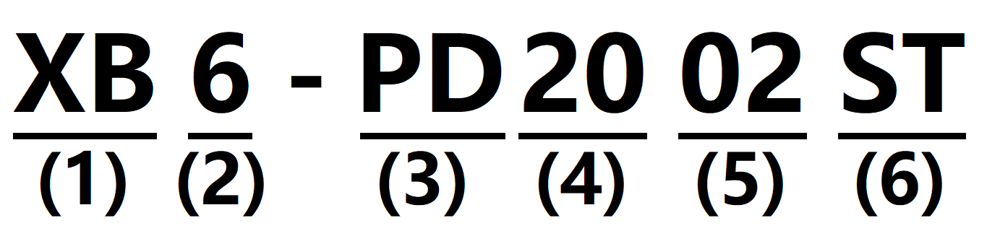

serial number | hidden meaning | Description of values
(1) | Bus Type | XB：X-bus backplane bus
(2) | Product Series | 6: slice
(3) | Bus protocol | PD: PROFIBUS-DP  CL: CC-Link  PN: PROFINET  EI: EtherNet/IP  EC: EtherCAT  CB: CC-Link IE Field Basic  CT: CC-Link IE TSN
(4) | Power supply | 20:2A
(5) | Number of Bus Interfaces | 02: Dual bus interface (Profibus connector supports connection of the former and latter stations)
(6) | Module Type | ST: Kit of power supply, coupler, and cover plate

I/O module Designation rules
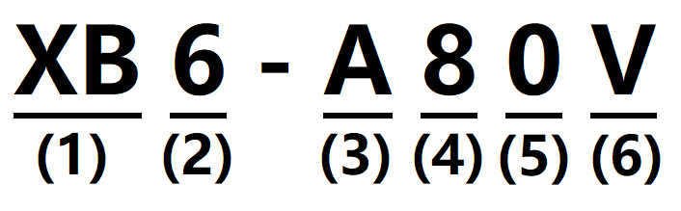
serial number | hidden meaning | Description of values
(1) | Bus Type | XB: X-bus
(2) | Product Series | 6: slice
(3) | I/O Module Type | A: Analog  Blank：Digital
(4) | Number of inputs | Analog：0、4、8  Digital：0、8、16、32
(5) | Number of outputs | Analog：0、4、8  Digital：0、8、16、32
(6) | I/O Characteristics | Digital |  |  | Analog
 |  | Code | Input | Output | Code | Description
 |  | A | NPN | NPN, 0.5A | V | -10~+10 V, 0~+10 V
 |  | B | PNP | PNP, 0.5A | I | 4~20 mA, 0~20 mA
 |  | BW | PNP | PNP, 0.25A | TM | Resistance Temperature Detector  (RTD), thermocouple (TC)
 |  | N | NPN/PNP | -
 |  | AN | - | NPN, 0.1A
 |  | BN | - | PNP, 0.1A

List of Common Modules
model number | Product Description
XB6-PD2002ST | PROFIBUS-DP Coupler Kit(power supply + coupler + cover plate)
XB6-P2000 | Extension Power Module
XB6-3200A | 32-channel digital input module, NPN type
XB6-3200B | 32-channel digital input module, PNP type
XB6-0032A | 32-channel digital output module, NPN type
XB6-0032b/XB6-0032bw | 32-channel digital output module, PNP type
XB6-1600A | 16-channel digital input module, NPN type
XB6-1600B | 16-channel digital input module, PNP type
XB6-0016A | 16-channel digital output module, NPN type
XB6-0016b/XB6-0016bw | 16-channel digital output module, PNP type
XB6-0800A | 8-channel digital input module, NPN type
XB6-0800B | 8-channel digital input module, PNP type
XB6-0008A | 8-channel digital output module, NPN type
XB6-0008b/XB6-0008bw | 8-channel digital output module, PNP type
XB6-1616A | 16-channel digital input/output module, NPN type
XB6-1616B/XB6-1616BW | 16-channel digital input/output module, PNP type
XB6-3200N | 32 channels of digital inputs, NPN/PNP compatible
XB6-0032AN | 32-channel digital output, NPN type
XB6-0032BN | 32-channel digital output, PNP type
XB6-A80V | 8-channel analog voltage input module | Optional ranges：  0~+10 V -10~+10 V
XB6-A40V | 4-channel analog voltage input module
XB6-A08V | 8-channel analog voltage output module
XB6-A04V | 4-channel analog voltage output module
XB6-A80I | 8-channel analog current input module | Optional ranges：  0~20 mA 、4~20 mA
XB6-A40I | 4-channel analog current input module
XB6-A08I | 8-channel analog current output module
XB6-A04I | 4-channel analog current output module
XB6-0012J | 12-Channel Relay Output Module
XB6-A40TM | 4-channel RTD and thermocouple temperature acquisition module
XB6-A80TM | 8-channel RTD and thermocouple temperature acquisition module
XX6-C18_2 | Public Side Extension Module

Product Parameters

General parameters
General technical parameters
Size | Power module | 106X61X22.5 mm
 | Coupler module | 106X61X22.5 mm
 | I/O Modules | 106X73X25.7 mm
weights | Power module | 110 g
 | Coupler module | 80 g
 | I/O Modules | 90 g
Operation temperature | -10℃~+60℃
Storage temperature | -20℃~+75℃
Relative humidity | 95%, non-condensing
Protection class | IP20

Power supply parameters
Power supply parameters
Power module | Working power supply | 24 VDC (18V~30V)
 | Output voltage | 5 VDC
 | Output Current | 2 A
Coupler module | Working power supply | 5 VDC
 | Working Current | 100 mA
I/O Module | Working power | 5 VDC

Interface parameters
PROFIBUS-DP interface parameters (XB6-PD0002 coupler)
Bus protocol | PROFIBUS-DP
Data transmission medium | PROFIBUS-DP special cable (shielded twisted pair RS-485 communication cable)
Range of communication functions | DPV0
Transmission rate | 9.6 Kbps ~ 12 Mbps
Automatic detection of transmission rate | Supported
Transmission rate versus bus length | 9.6 Kbps ~ 187.5 Kbps | 500 Kbps | 1500 Kbps | 3000 Kbps ~ 12000 Kbps
 | ≤1000 m | ≤400 m | ≤200 m | ≤100 m
Maximum transmission current | 70 mA
Maximum I/O communication data length | 160 Bytes input  160 Bytes output
Bus interface | PROFIBUS-DP interface, RS-485 DP communication 9-pin socket

Digital parameters
Digital input
rated voltage | 24 VDC (18V~30V)
Number of signal points | 8, 16, 32
Signal Type | NPN/ PNP
"0" signal voltage (PNP) | -3~+3 V
"1" signal voltage (PNP) | 15~30 V
"0" signal voltage (NPN) | 15~30 V
"1" signal voltage (NPN) | -3~+3 V
Input Filter | 3 ms
Input Current | 4 mA
Isolation method | Optically-coupled isolation
Isolated Withstand Voltage | 500 VAC
Channel Indicator | Green LED light
Digital output
Rated voltage | 24 VDC (18V~30V)
Number of signal points | 8, 16, 32
Signal Type | NPN/ PNP
Load Type | Resistive load, inductive load
Single channel rated current | NPN type Max: 500 mA  PNP type Max: 500 mA  BW type Max: 250mA
port protection | Overvoltage and overcurrent protection
Isolation method | Optically-coupled isolation
Isolated Withstand Voltage | 500 VAC
Channel Indicator | Green LED light
Relay output
Rated voltage | 24 VDC (18V~30V)
Number of signal points | 12
Isolation method | Optocouplers, Relays
Rated load | 2 A
Channel Indicator | Green LED light

Analog parameters

Technical Parameters
Analog input
Input Points | 4, 8
Input signal (voltage type) | 0~+10 V, -10 V~+10 V (range adjustable)
Input signal (current type) | 0~20 mA, 4~20 mA (range adjustable)
Resolution | 16 bits
Sampling rate | XB6-A40V, XB6-A80V, XB6-A40I, XB6-A80I |  | ≤1 ksps
Accuracy | XB6-A40V, XB6-A80V, XB6-A40I, XB6-A80I |  | ±0.1%
Input Impedance (Voltage Type) | ≥2 kΩ
Input impedance (current type) | 100 Ω
Isolated Withstand Voltage | 500 VAC
Channel Indicator Lights | Green LED light
Temperature Input
channel number | 4, 8
Sensor type | Thermocouple | Thermal resistor |  | Resistor
connective type | 2-wire method | 2-wire, 3-wire method |  | 2-wire method
 | K: -200~1370℃  J: -200~1200℃  E: -200~1000℃  S: -50~1690℃  B： 50~1800℃ | Pt100: -200~850°C  Pt200: -200~600℃  Pt500: -200~600℃  Pt1000: -200~600°C |  | 15Ω~3kΩ
Accuracy | ± 0.3% | ±1°C |  | ±0.1%
Sensitivity | 0.1°C |  |  | ±0.1Ω
Resolution | 16 bits (int type)
Channel Indicator | Green LED light

Analog output
Output Points | 4, 8
Output signal (voltage type) | 0~+10 V, -10~+10 V (range adjustable)
Output signal (current type) | 0~20 mA, 4~20 mA (range adjustable)
Resolution | 16 bits
Accuracy | XB6-A04V, XB6-A08V, XB6-A04I, XB6-A08I | ±0.1%
Load impedance (voltage type) | ≥2 kΩ
Load impedance (current type) | ≤200 Ω
Isolated Withstand Voltage | 500 VAC
Channel Indicator Lights | Green LED light
Note: Analog voltage modules do not support up and down overflow and overshoot, analog current modules support up and down overflow and overshoot.

Voltage Input/Output Range Selection and Code Value Table
Voltage I/O range selection and code value range
Range Selection | 0 | 1 | 2 | 3
Measurement range | -10 V~+10 V | 0~+10 V | -10 V~+10 V | 0~+10 V
Code Value Range | -32768~32767 | 0~32767 | -27648~27648 | 0~27648
Voltage Input formula | D=(65535/20)*U | D=(32767/10)*U | D=(55296/20)*U | D=(27648/10)*U
voltage output  formula | U=(D*20)/65535 | U=(D*10)/32767 | U=(D*20)/55296 | U=(D*10)/27648
Code value table | See Table 3-1 Voltage Code Value .
Note: D: code value; U: voltage.

Table 3-1 Voltage Code Values
Range  Voltage | 0 (default) | 1 | 2 | 3
 | -10 V~+10 V | 0~+10 V | -10 V~+10 V | 0~+10 V
 | code value | code value | code value | code value
-10 | -32768 | - | -27648 | -
-9 | -29491 | - | -24883 | -
-8 | -26214 | - | -22118 | -
-7 | -22937 | - | -19354 | -
-6 | -19661 | - | -16589 | -
-5 | -16384 | - | -13824 | -
-4 | -13107 | - | -11059 | -
-3 | -9830 | - | -8294 | -
-2 | -6554 | - | -5530 | -
-1 | -3277 | - | -2765 | -
0 | 0 | 0 | 0 | 0
1 | 3277 | 3277 | 2765 | 2765
2 | 6554 | 6553 | 5530 | 5530
3 | 9830 | 9830 | 8294 | 8294
4 | 13107 | 13107 | 11059 | 11059
5 | 16384 | 16384 | 13824 | 13824
6 | 19661 | 19660 | 16589 | 16589
7 | 22937 | 22937 | 19354 | 19354
8 | 26214 | 26214 | 22118 | 22118
9 | 29491 | 29490 | 24883 | 24883
10 | 32767 | 32767 | 27648 | 27648
 | D= (65535/20) * U | D= (32767/10) * U | D= (55296/20) * U | D= (27648/10)*U
 | U= (D*20) / 65535 | U= (D*10) / 32767 | U= (D*20) / 55296 | U= (D*10) / 27648
Note: For analog voltage input modules, the maximum code value is displayed when the channel input voltage exceeds 10V. For analog voltage output module, if the code value setting exceeds the maximum code value corresponding to the range in the table, all channels will output 10V.

Current Input/Output Range Selection and Code Value Table
Analog Current Input/Output Range Selection and Code Value Range
Range Selection | 0 | 1 | 2 | 3
Measurement range | 4~20 mA | 0~20 mA | 4~20 mA | 0~20 mA
Code Value Range | 0~65535 |  | 0~27648
Current input formula | D=65535/16*I-16384 | D=(65535/20)*I | D=(27648/16)*I-6912 | D=(27648/20)*I
Current Output Formula | I=(D+16384)*16/65535 | I=(D*20)/65535 | I=((D+6912)*16)/27648 | I=(D*20)/27648
code value table | See Table 3-2 Current Code Values.
Note: D: Code value; I: current.

Tables 3-2 Current Code Values
Range Selection  Range  Current | 0 (default) | 1 | 2 | 3
 | 4~20mA | 0~20mA | 4~20mA | 0~20mA
 | code value | code value | code value | code value
0 | - | 0 | - | 0
1 | - | 3277 | - | 1382
2 | - | 6554 | - | 2765
3 | - | 9830 | - | 4147
4 | 0 | 13107 | 0 | 5530
5 | 4096 | 16384 | 1728 | 6912
6 | 8192 | 19661 | 3456 | 8294
7 | 12288 | 22937 | 5184 | 9677
8 | 16384 | 26214 | 6912 | 11059
9 | 20479 | 29491 | 8640 | 12442
10 | 24575 | 32768 | 10368 | 13824
11 | 28671 | 36044 | 12096 | 15206
12 | 32767 | 39321 | 13824 | 16589
13 | 36863 | 42598 | 15552 | 17971
14 | 40959 | 45875 | 17280 | 19354
15 | 45055 | 49151 | 19008 | 20736
16 | 49151 | 52428 | 20736 | 22118
17 | 53247 | 55705 | 22464 | 23501
18 | 57343 | 58982 | 24192 | 24883
19 | 61439 | 62258 | 25920 | 26266
20 | 65535 | 65535 | 27648 | 27648
21 | 65535 | 65535 | 29376 | 29030
22 |  |  | 31104 | 30413
22.81 |  |  | 32511 | 31538
22.96 |  |  | 32767 | 31743
23 |  |  |  | 31795
23.52 |  |  |  | 32511
23.70 |  |  |  | 32767
24
25
 | D=65535/16*I- 16384 | D= (65535/20)*current | D= (27648/16) * I- 6912 | D= (27648/20)*I
Note: When the input current of range 2 > 22.81 mA, the code values all show 32767; when the specified code value is > 32511, the output current is 22.81 mA.
When range 3 input current > 23.52 mA, the code values all show 32767; when specified code values > 32511, the output current is 23.52 mA.

Common terminal expansion module parameters
Common terminal
Rated voltage | 125 VDC/AC 250V
Rated current | 8 A
Number of common terminals | 2 sets

Panel

Coupler Panel

Coupler Structure
Name and function description of product components
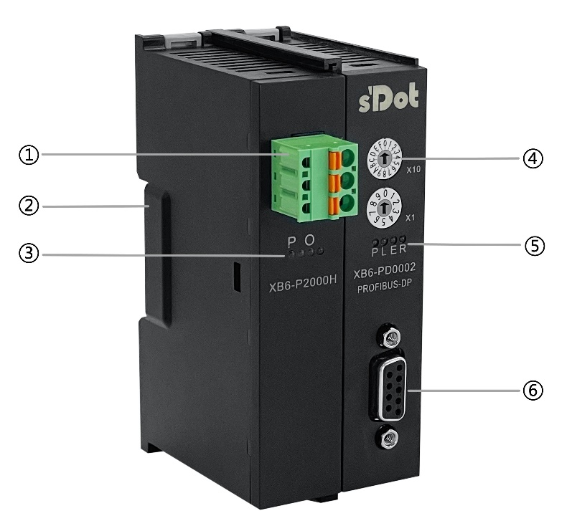
serial number | name (of a thing) | clarification
① | Power supply terminal block | Spring-loaded terminal blocks
② | Guideway slot | For DIN 35mm rail fixing
③ | Power marking, indicator light | Indicates power status
④ | Rotary switch and marking | Setting the station number
⑤ | System identification, indicator | Indicates power supply and module operation status
⑥ | DP bus interface | RS-485 DP communication 9-pin socket

Rotary switch
Rotary Dial Description
The XB6-PD2002ST coupler kit and I/O module combination structure acts as a DP slave in a PROFIBUS-DP network with an adaptable transmission rate (baud rate), which needs to be set first to its station number in the network.
The station number is set using rotary dip switches, and the rotary switches and meanings are shown in the table below:
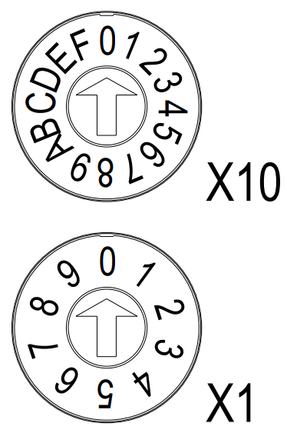
Markings | Usage | Setting range | figure | note
X10 | Setting the tens/hundreds digit | 0~C | sixteenth digits | The station number setting range is 0~127, X10 is the high (ten/hundred) digit dialing code, X1 is the low (single) digit dialing code, station number = high digit x 10 + low digit.
X1 | Setting single digit | 0~9 | ten digits
Note: The station number setting range is 0 to 127, 0 is generally used for programming devices, 1 is generally used for operator stations, 126 is reserved for factory devices that do not have switch settings and must be re-addressed over the network, and 127 is used for broadcasting, so the valid address range for DP devices is 2 to 125.

Schematic diagram of station number rotary dialing setting

Station number setting | Dialing code setting | Set value | Station number value
X10 | Tenth/Hundredth Digit Dialing Code | 0~C | X10
 |  | 0 | 0
 |  | 1 | 10
 | ┇ | ┇ | ┇
 |  | B | 110
 | 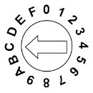 | C | 120
X1 | single-digit dialing code | 0~9 | X1
 | 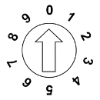 | 0 | 0
 |  | 1 | 1
 | ┇ | ┇ | ┇
 | 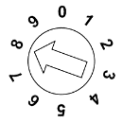 | 8 | 8
 |  | 9 | 9
Remarks:
- Please use a slotted screwdriver with an opening of 2mm.
- If it is necessary to change the station number during communication, after setting the new station number, power must be reapplied for the new setting to take effect.
- If the station number is out of the setting range, the module will have a communication error or will not be able to connect to the master station.

Indicator light function
Description of IDs and indicators of the power module
ID | Color | state of affairs | State Description
P | Green | ON | Normal status of working power supply
 |  | Flashing | 80% overload. The power supply to real stage load is cut off
 |  | OFF | Unpowered or abnormal power supply
O | Red | OFF | Not overloaded
 |  | ON | 90% overload
 |  | Flashing | 80% overload. The power supply to real stage load is cut off

Description of IDs and indicators of the coupler module
Name | ID | color | state of affairs | State Description
Power indicator | P | Green | ON | Normal status of power supply
 |  |  | OFF | Unpowered or abnormal power supply
System Indicator | L | Green | ON | The I/O module is connected, X-bus system is interacted
 |  |  | Flashing 1Hz | The I/O module is connected, X-bus system is ready to interact
 |  |  | Flashing 5Hz | The I/O module is not connected, X-bus system  configuration abnormal
 |  |  | OFF | The I/O module is not connected or abnormal connection
Warning indicator | E | Red | ON | Module operating abnormally (e.g. topology inconsistency, overload of the number of connected modules, abnormal initialization, PROFIBUS-DP communication disconnection)
 |  |  | OFF | Module works without anomaly
Operation status indicator | R | Green | ON | The system is operating normally
 |  |  | OFF | Operating abnormality (PROFIBUS-DP communication disconnected)

I/O Module Panel
Names and function descriptions of modules

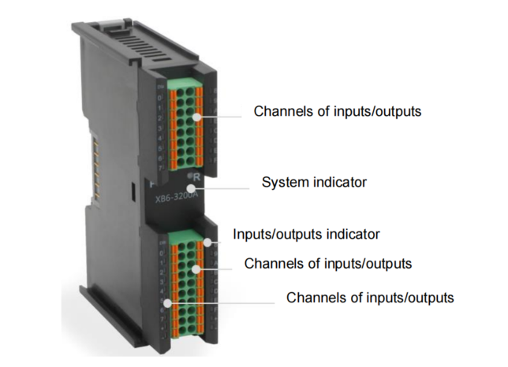

I/O Module Indicator Description
markings | color | state of affairs | State Description
P | GREEN | ON | Normal status of working power supply
 |  | OFF | Unpowered or abnormal power supply
R | GREEN | ON | Normal system operation
 |  | Flashing 1 Hz | I/O module connected, X-bus system ready for interaction
 |  | OFF | Unpowered, no X-bus data interaction, or abnormal status
Input Channel Indication | GREEN | ON | Presence of signal input in module detection channel
 |  | OFF | Absence of signal input in module channel or abnormal signal input
Output Channel Indication | GREEN | ON | Presence of signal output in module channel
 |  | OFF | Absence of signal output in module channel or abnormal signal output

Installation and Disassembly

Installation Instruction
Installation and disassembly precautions
- Ensure that the cabinet is well ventilated ((such as the addition of exhaust fans to cabinets).
- Do not install this equipment next to or above equipment that may cause overheating.
- Be sure to install the module vertically and maintain air circulation around it (at least 50 mm air circulation space above and below the module).
- After the modules are installed, remember to install guide rail fasteners at both ends to fix them.
- Installation/disassembly operation may only be carried out after the power supply is cut off.

Minimum clearance for module mounting (≥50mm)
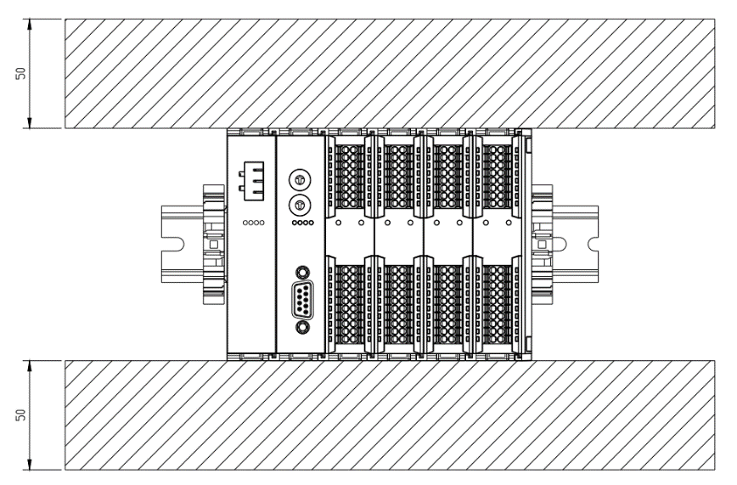

Ensure that the module is installed vertically
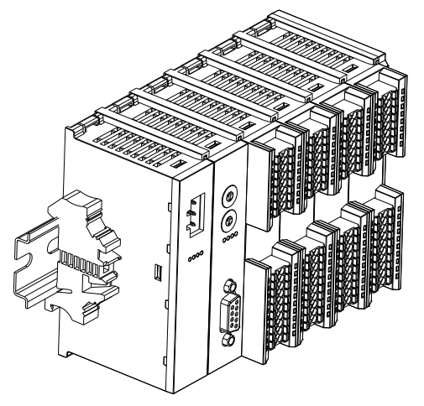
Make sure to install the rail fasteners
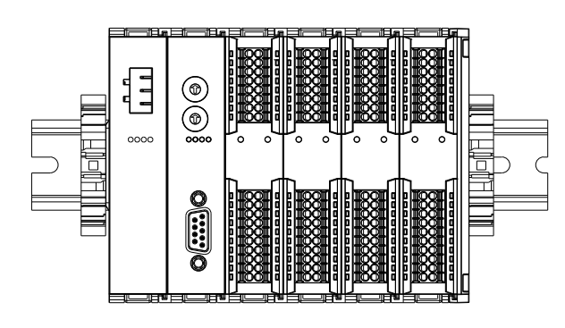

Installation and disassembly steps
Module Installation and Removal
Module Installation Steps | 1. Install the power module on the fixed guide rail first.
2. Install the coupler and the required I/O modules on the right side of the
power module.
3. After installing all required I/O modules, install the end cover to complete
module assembly.
4. Install guide rail fasteners at both ends of the power module and end
cover to fix the module.
Module disassembly steps | 1. Loosen the rail fasteners at both ends of the module.
 | 2. Pry loose the module snap fitting with a slotted screwdriver
 | 3. Pull out the removed module.

Installation schematic diagram
Power Module Installation |  | Steps
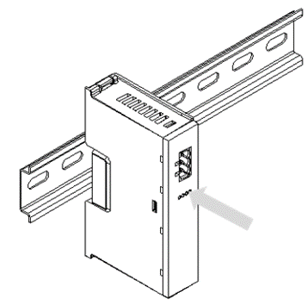

Align the power module
guide rail slot vertically
with the guide rail, as
shown in the figure①

①
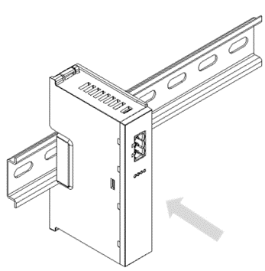

Press the power
module with force until
a "click" sound is heard.
The module is now
installed in place, as
shown in the figure②

②

Coupler Module Installation |  | Steps
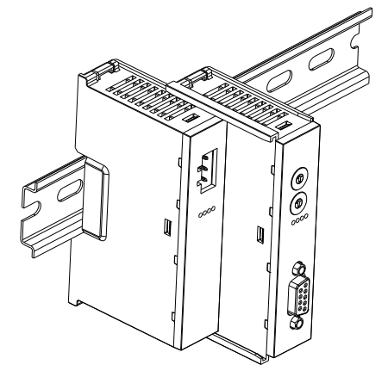

Align the left slot of the coupler module with the right side of the power supply module and push it in as shown in figure ③ on the left.
Press firmly on the power module, and when you hear a "click" sound, the module is installed in place.
③

I/O Module Installation |  | Steps
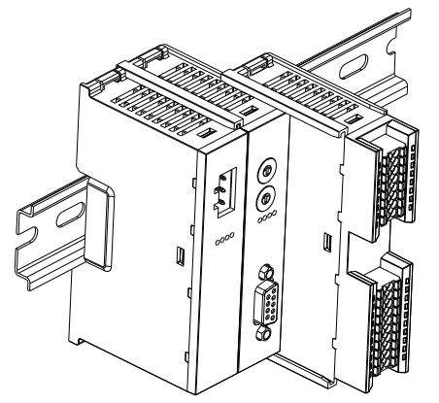

Install the required I/O modules one by one as shown in Figures ④ and ⑤ on the left, following the procedure of installing the coupler module in the previous step.

④
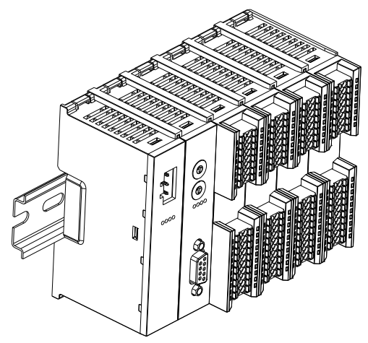

⑤

End cap retrofit |  | Steps
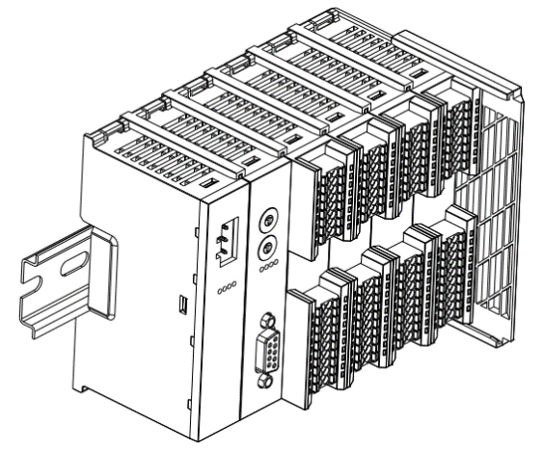

Install the end cap on the right side of the last module as shown in Figure⑥ on the left, and refer to the installation method of the coupler module.

⑥

Retrofitting of guide rail fixings |  | Steps
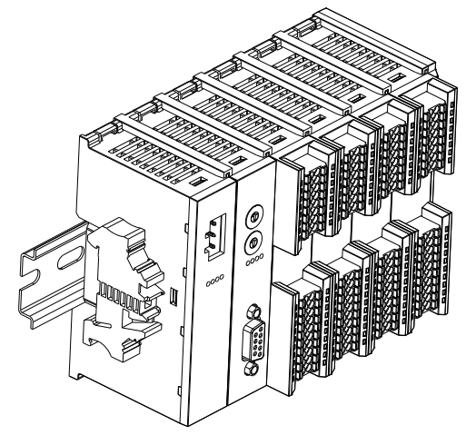

Install and lock the rail retainer firmly against the left side face of the coupler, as shown in Figure⑦ at left.

⑦
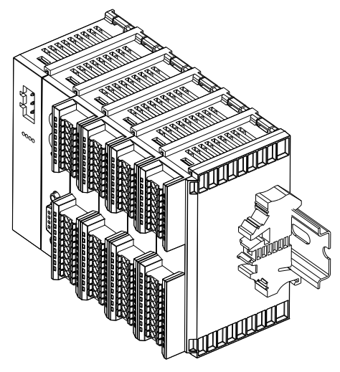

Install the rail fixture on the right side of the end cap, first push the rail fixture firmly in the direction of the coupler to ensure that the module is mounted tightly, and use a screwdriver to lock the rail fixture as shown in Figure⑧ on the left.

⑧
Disassembly |  | Steps
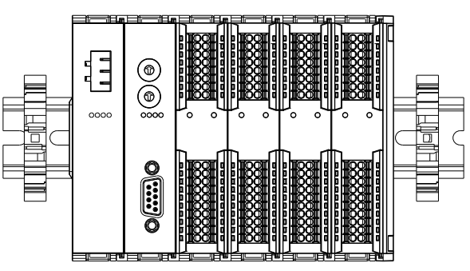

Loosen the rail retainer at one end of the module with a screwdriver and move it to one side, making sure there is clearance between the module and the rail retainer, as shown in Figure⑨ on the left.

⑨
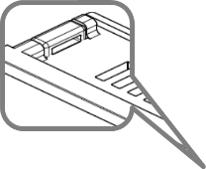
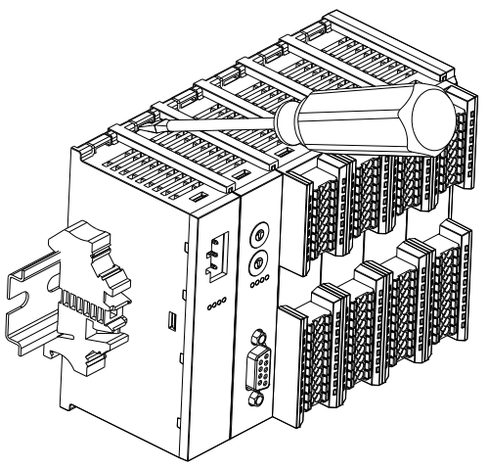

Insert a flat head start into the snap of the module to be removed, and apply pressure sideways in the direction of the module (hear the rattling sound), as shown in Figure⑩ on the left.
Note: Each module has a snap at the top and bottom, all operate in this way.

⑩
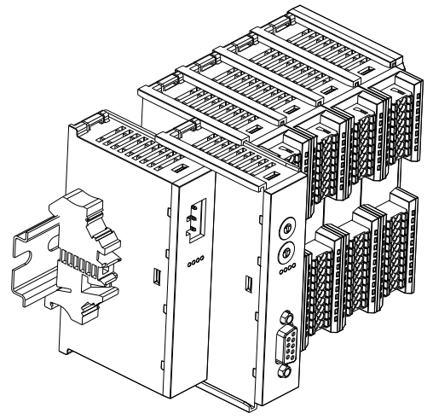

Remove the module by doing the opposite of installing the module, as shown in the left figure ⑪.

⑪

Dimension
Power module dimensions (Unit: mm)
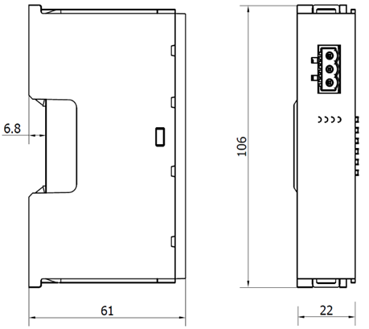

Coupler module dimensions (Unit: mm)
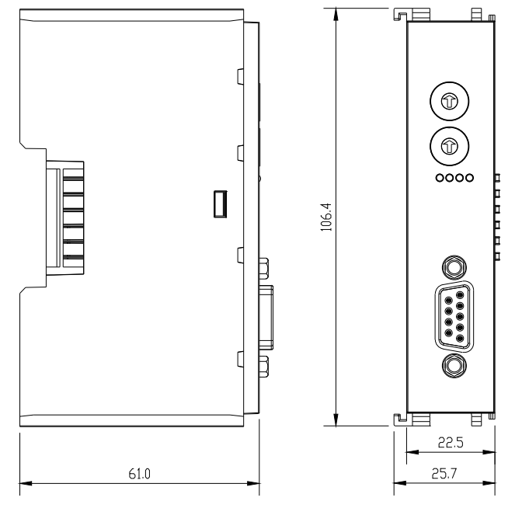

Extension power module dimensions (Unit: mm)
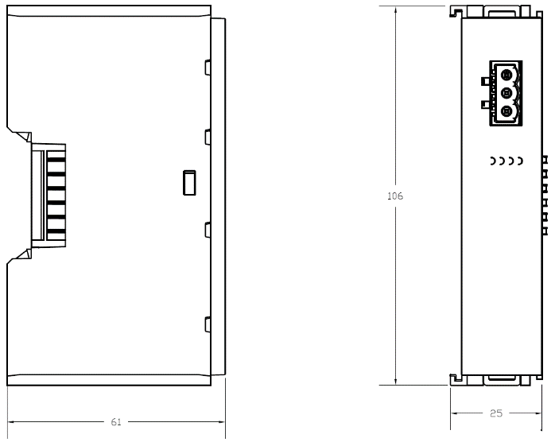

I/O module dimensions (Unit: mm)
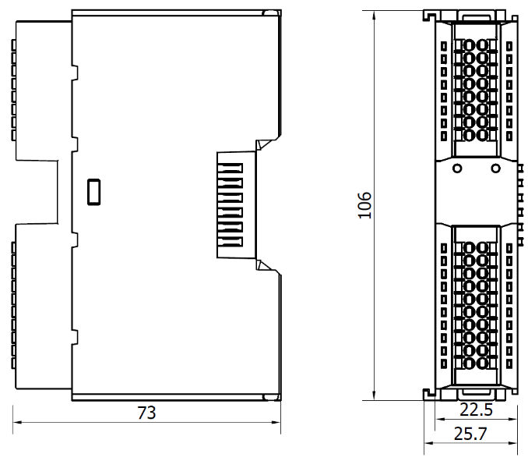

End cover module dimensions (Unit: mm)
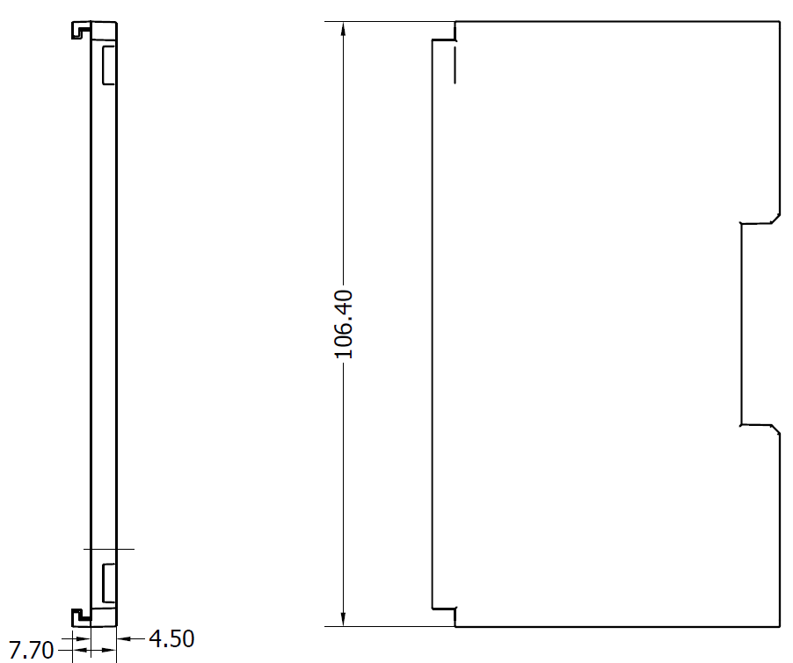
Note: All installed with DIN 35 mm standard guide rail, specification 35*7.5*1.0 (unit: mm)

Wiring

Wiring terminal
Wiring terminal
Signal wire terminal | Number of poles | 16 P
 | Number of poles | 20 P
 | Wire gauge | 22~17 AWG 0.3~1.0 mm²
Power terminal | Number of poles | 3P
 | Wire gauge | 22~16 AWG 0.3~1.5 mm²
Bus interface | PROFIBUS-DP interface | RS-485 DP communication 9-pin socket
 | Communication connectors | Profibus connector (DP communication 9-pin RS485 plug)
 | Communication cable | Shielded Twisted Pair RS-485 Communication Cable

Wiring instructions and requirements
Power wiring precautions
- The power supply on the module system side and that on the field side should be wired separately. Mixing should be avoided.PE must be reliably grounded.
⚫ PE should be grounded reliably.

Wiring tool required
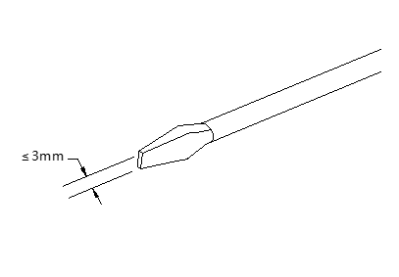
The power supply and signal line terminals adopt the screwless design, and the installation and removal of the cables can be operated with a slotted screwdriver (size: ≤3mm).
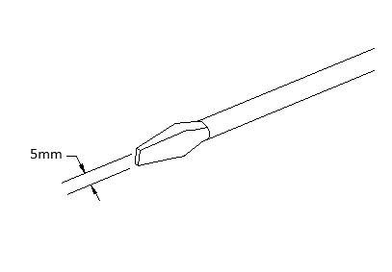
The bus interface is an RS-485 DP communication 9-pin socket, and a Profibus bus connector is required between the module and the communication cable.
Insert the connector into the bus connector of the coupler after aligning the connector with the socket, and then tighten the screws on the connector with a slotted screwdriver. Both the installation and removal of the connector can be operated with a sotted screwdriver (size: ≤5mm).

Stripping Length Requirements
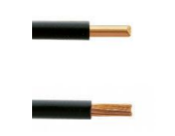
The recommended cable stripping length for the power and signal line terminals is 10 mm.
Wiring method
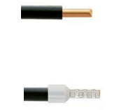
For single stranded hard wires, after stripping the corresponding length of wire, press down the button while inserting the single stranded wire.

Multi-stranded flexible wires, after stripping the corresponding length of wire, can be directly connected or supporting the use of the corresponding standard specifications of the cold compression end (tube-type insulated terminal, the reference specifications are shown in the table below), press down the button at the same time the line will be inserted.

Terminal specifications are shown in the following table:
Tube Insulation End Specification Sheet
Specification | Model | Cable section area (mm²)
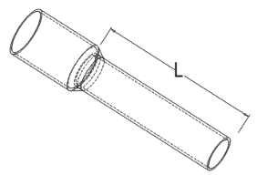  Length of tubular insulated terminal L ≥10 mm | E0310 | 0.3
 | E0510 | 0.5
 | E7510 | 0.75
 | E1010 | 1.0
 | E1510 | 1.5

Bus connector wiring method
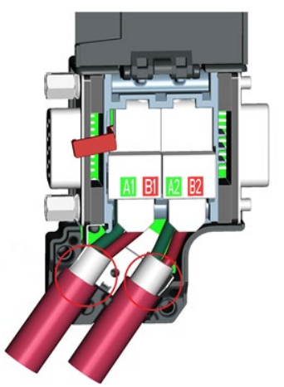

The bus connector and the communication cable need to be connected to each other as shown in the figure on the left, steps are as follows:
- Strip the insulation of the communication cable by about 5mm with a wire stripping tool.
- Insert the two wires of the communication cable into the junction box, the green wire corresponds to ports A1 and A2 and the red wire corresponds to ports B1 and B2.
- Once the wire insertion is complete, fix the wires with the screws on the junction box.
- Press the cable into the groove at the bottom of the junction box.
- Cover the connector housing cover and tighten with screws.
- There is a red toggle switch on the Profibus connector. When use it, needs to toggle the toggle switches on the first and last two connecting terminal devices to the ON position, and the bus connector at the middle end to the OFF position.

- When multiple couplers are connected, the bus connector is wired as shown below.
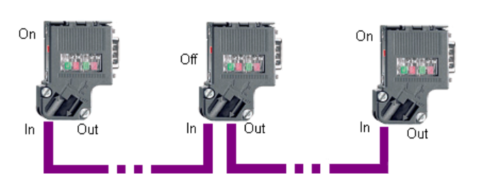
Note: The bus connector at the end of the network should have the DP cable connected to the "In" connector and the terminating resistor should be in the "On" position. The terminating resistor at the middle of the network should be placed in the "Off" position.

Power supply wiring: 3P terminal of power module
Connect the DC24V power module using the given wiring method based on the circuit shown in the figure below, and meanwhile ground the PE reliably (twisted pair cable is recommended for power supply)
- Figure 6-1: Wiring diagram of coupler, IO modules, and power module in sequence
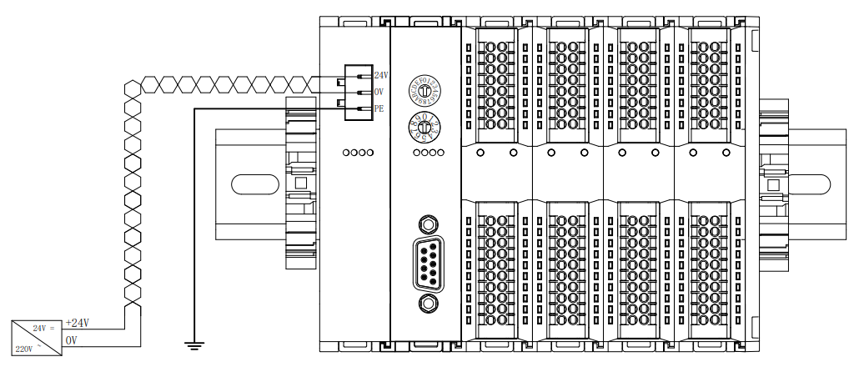
Figure 6-1

- Figure 6-2: Wiring diagram of coupler, IO modules, power module, IO modules, and power module in
sequence
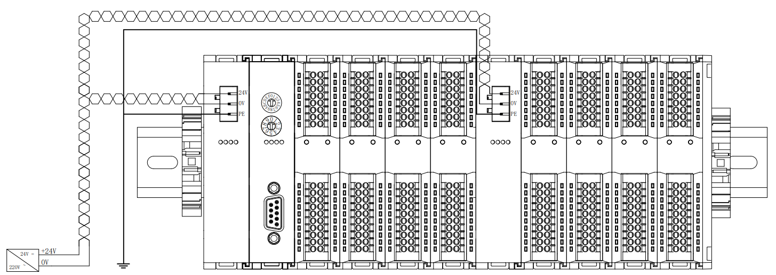
Load power supply wiring: 20P terminal on the field side
Refer to the corresponding I/O module wiring diagram and wiring method to press the signal wire cable into the terminal block.
The load power supply is powered by 24 VDC power supply. Referring to the wiring method, connect the power supply according to the circuit shown in the following figure (refer to 6.3 I/O Module Wiring Diagram for details).
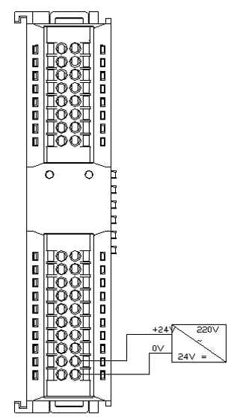
Signal terminal wiring: 16P\20P terminal
Press the signal cable into the wiring terminal by referring to the I/O module wiring diagram and wiring method.
Bus topology
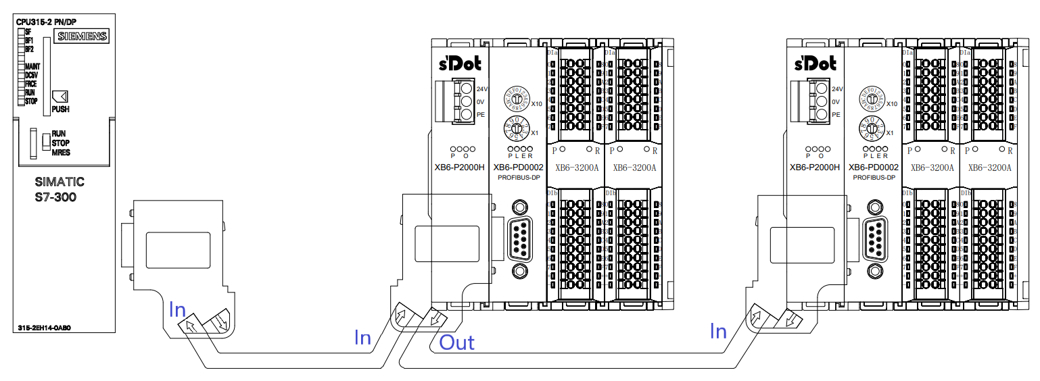

Bus connection
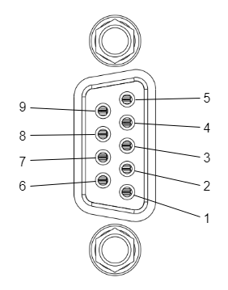
The bus cable is recommended to use a special PROFIBUS-DP cable with the bus wiring sequence shown in the figure below.
Pin | clarification
1 | Reserved
2 | Reserved
3 | RxD/TxD-P: Data cable B
4 | CNTR-P: RTS
5 | DGND: Ground for data signals and VPs
6 | VP: +5V supply for bus termination resistors only.
7 | Reserved
8 | RxD/TxD-P: Data Line A
9 | Reserved
housings | Grounding Connector

I/O module wiring diagram
XB6-3200N, XB6-0032AN, XB6-0032BN wiring diagrams refer to the XB6 Series_MIL Connector Type IO User's Manual.

XB6-3200A
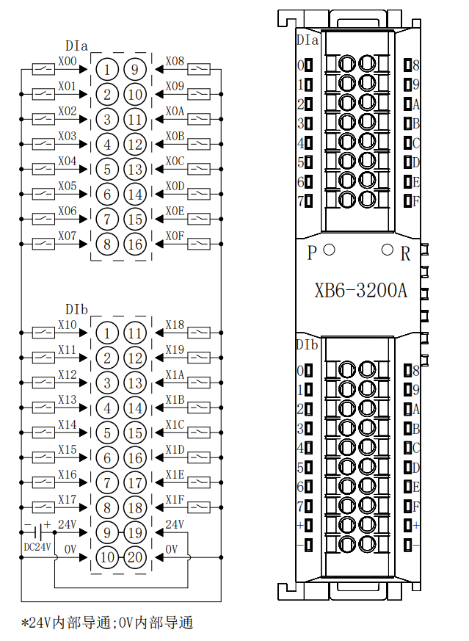
24V internal conduction; 0V internal conduction

XB6-3200B
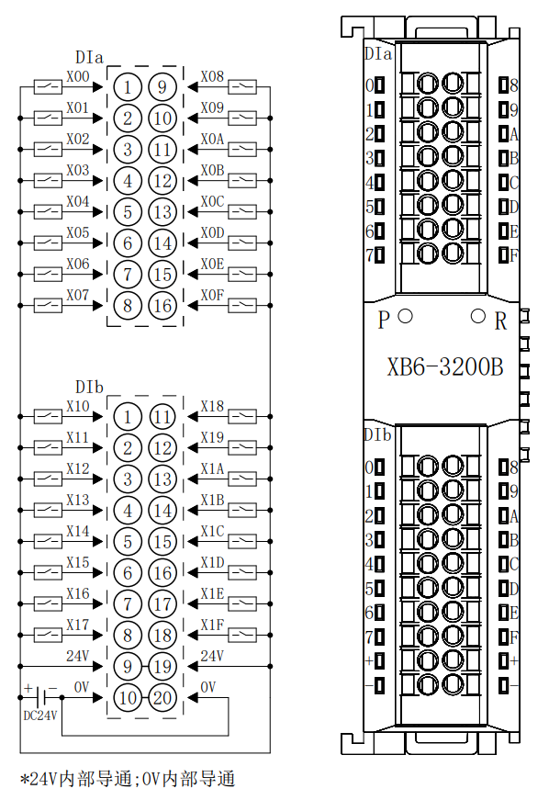
24V internal conduction; 0V internal conduction

XB6-1616A
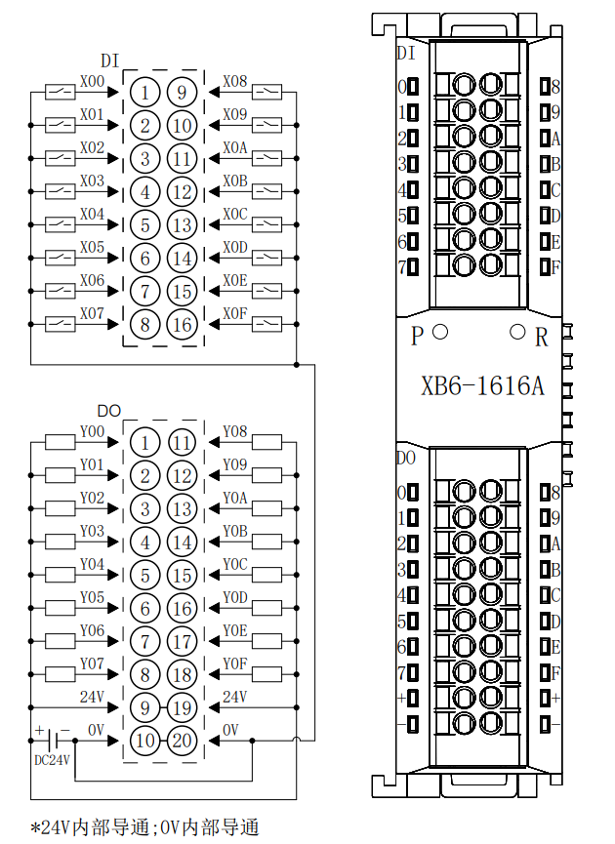
24V internal conduction; 0V internal conduction

XB6-1616B
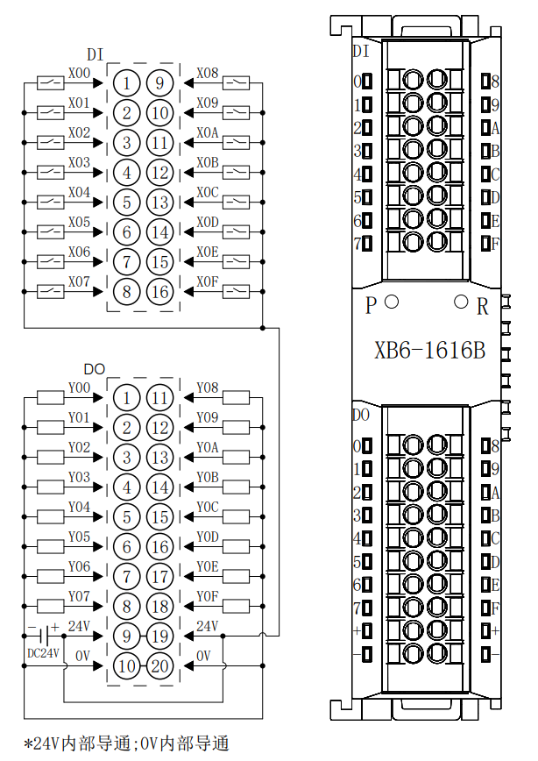
24V internal conduction; 0V internal conduction

XB6-1600A
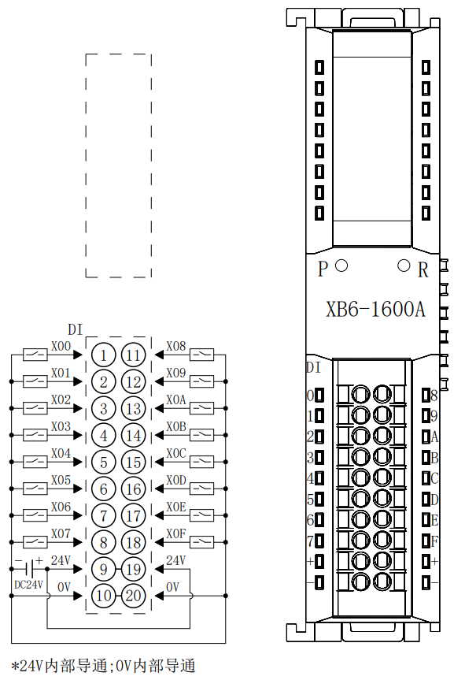
24V internal conduction; 0V internal conduction

XB6-1600B
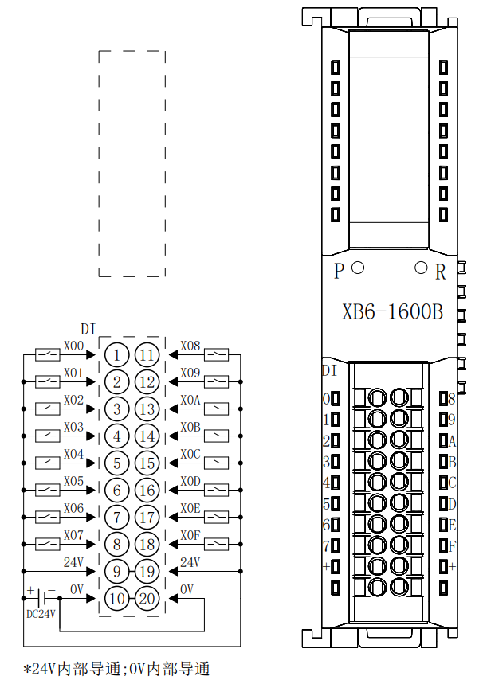
24V internal conduction; 0V internal conduction

XB6-0800A
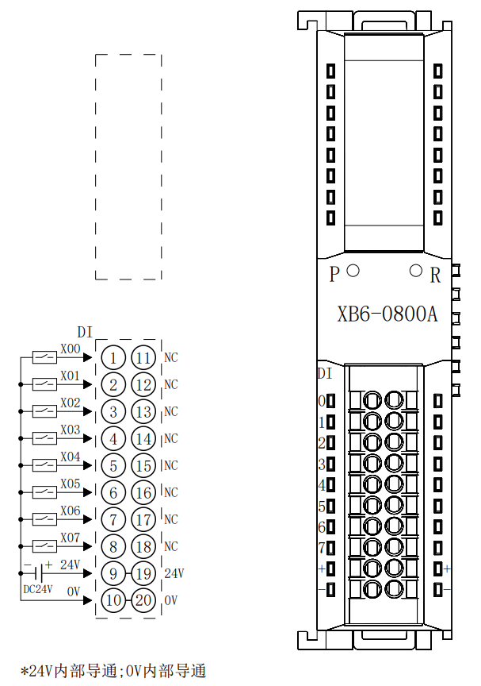
24V internal conduction; 0V internal conduction

XB6-0800B
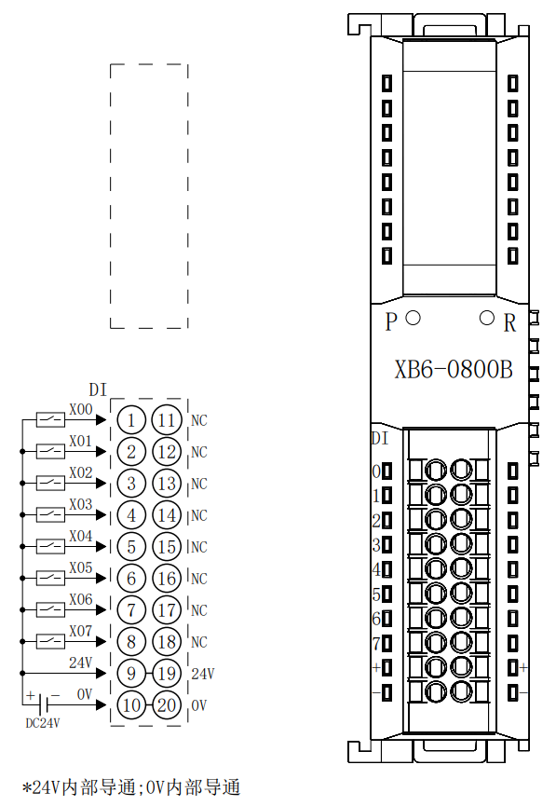
24V internal conduction; 0V internal conduction

XB6-0032A
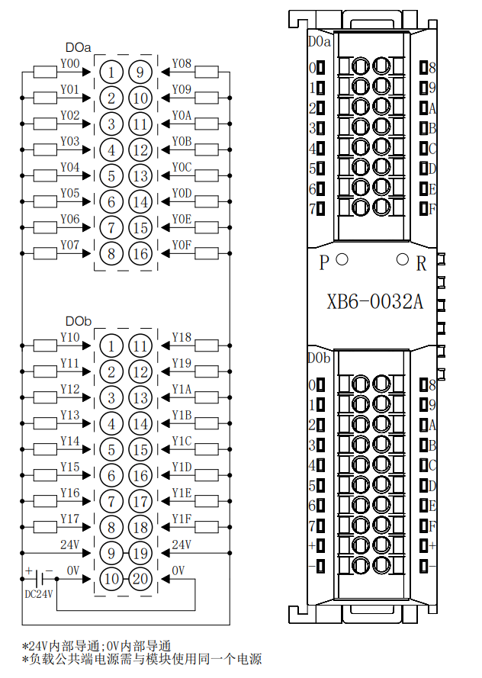
※24V internal conduction; 0V internal conduction
※The load common terminal power supply must use the same power supply as the module

XB6-0032B
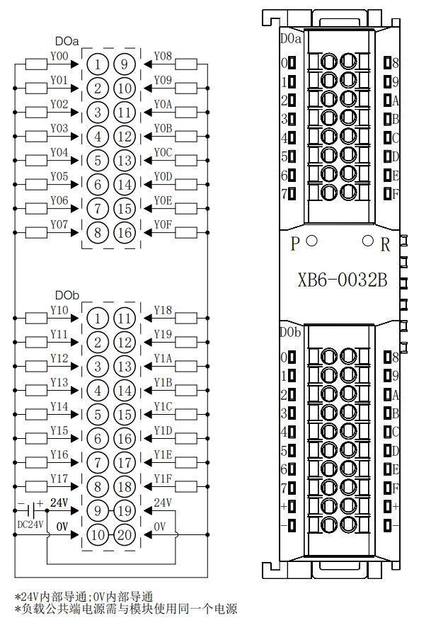
※24V internal conduction; 0V internal conduction
※The load common terminal power supply must use the same power supply as the module

XB6-0016A
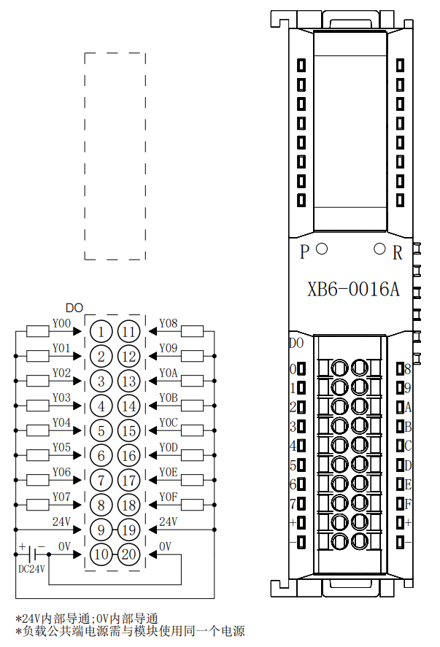
※24V internal conduction; 0V internal conduction
※The load common terminal power supply must use the same power supply as the module

XB6-0016B
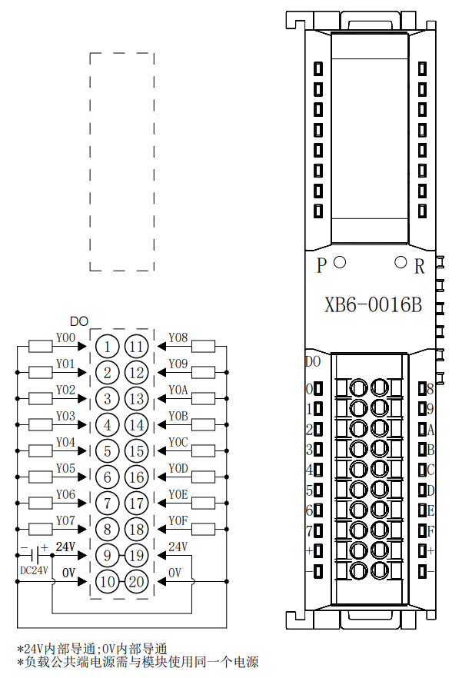
※24V internal conduction; 0V internal conduction
※The load common terminal power supply must use the same power supply as the module

XB6-0008A
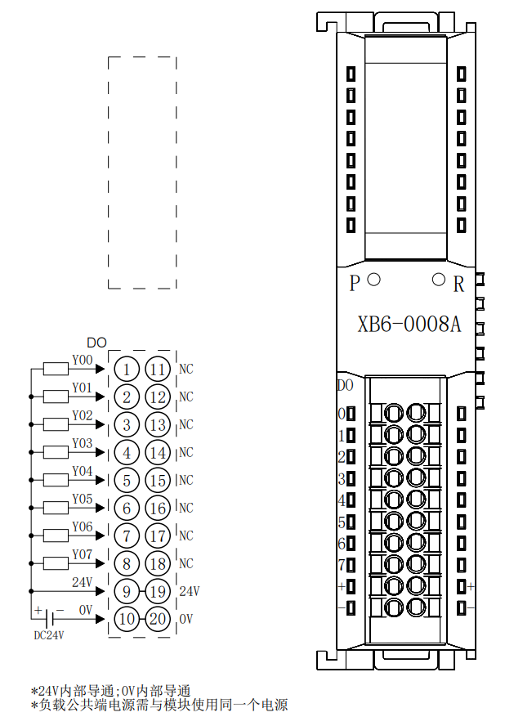
※24V internal conduction; 0V internal conduction
※The load common terminal power supply must use the same power supply as the module

XB6-0008B
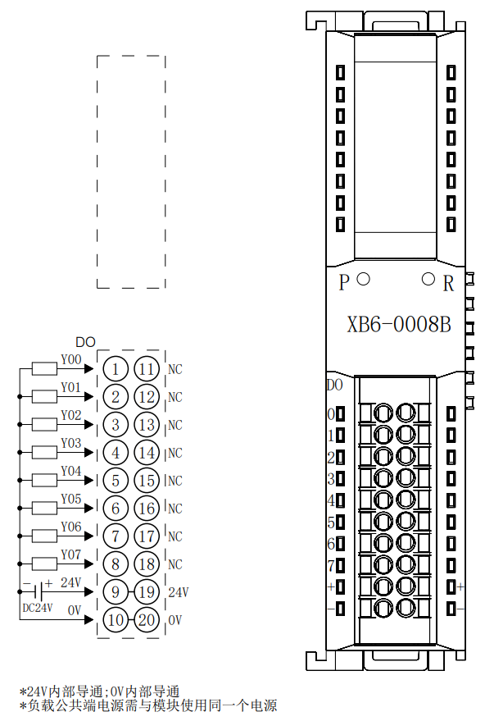
※24V internal conduction; 0V internal conduction
※The load common terminal power supply must use the same power supply as the module

XB6-0012J
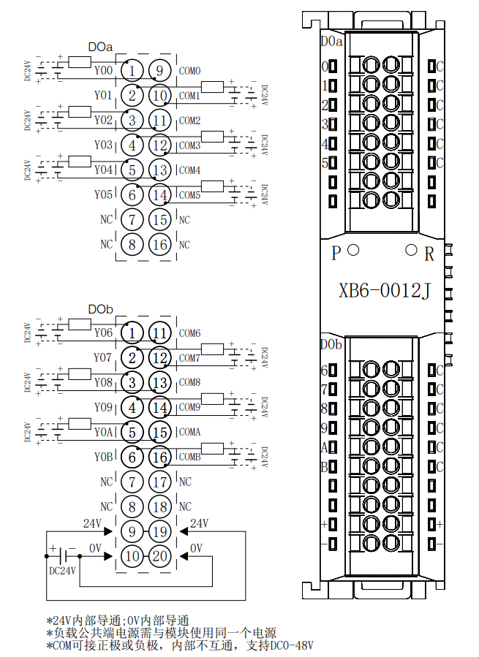
※24V internal conduction; 0V internal conduction
※The load common terminal power supply must use the same power supply as the module
※COM can be connected to the positive or negative pole, no internal communication, DC0-48V is supported

XB6-A80V
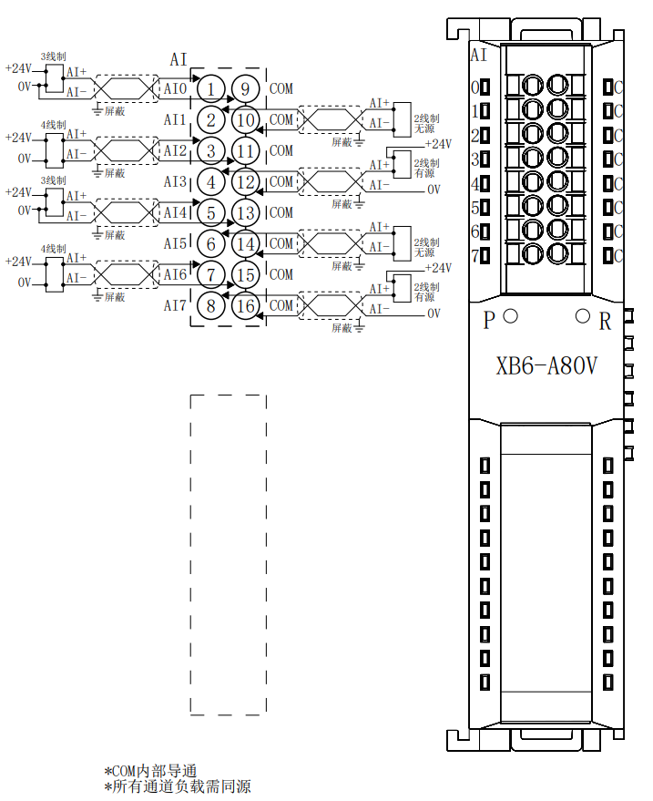
※COM internal conduction
※All channel loads require power

XB6-A80I
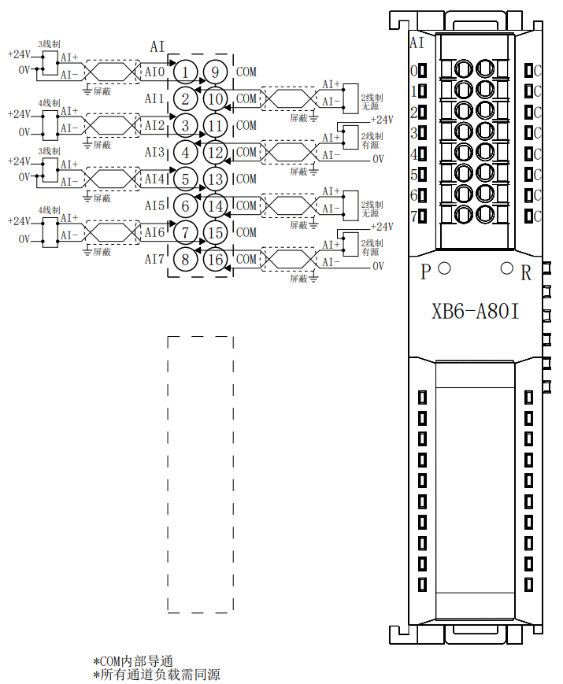
※COM internal conduction
※All channel loads require power

※COM internal conduction
※All channel loads require power

XB6-A40V
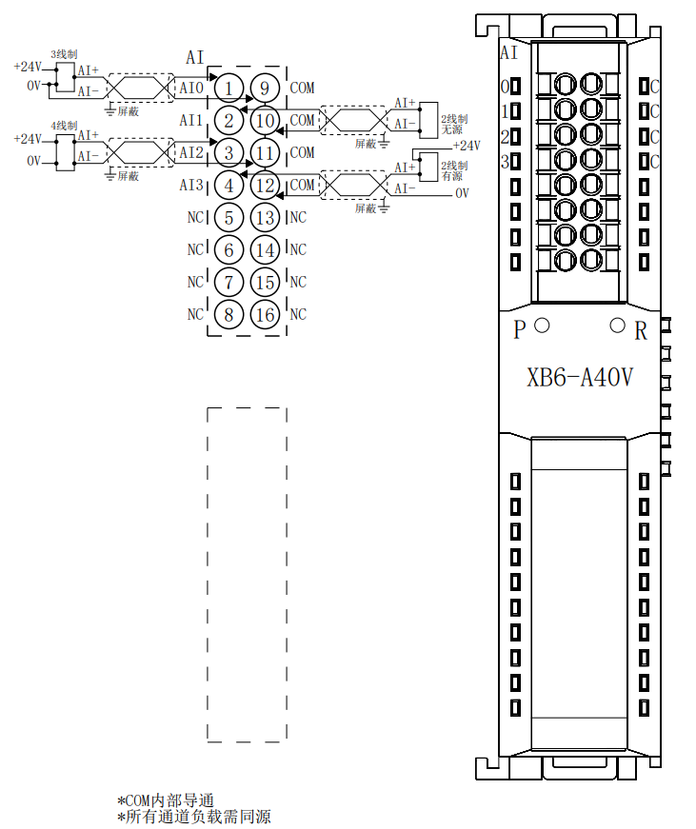
※COM internal conduction
※All channel loads require power

XB6-A40I
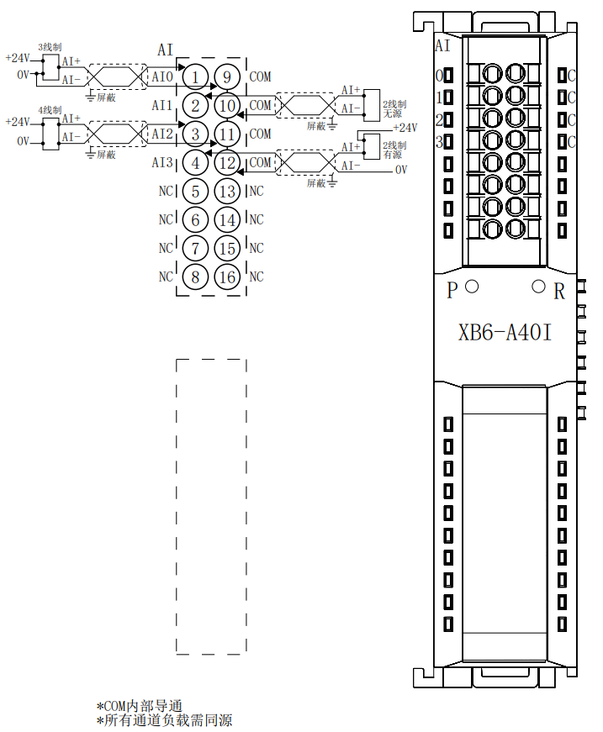
※COM internal conduction
※All channel loads require power

XB6-A08V
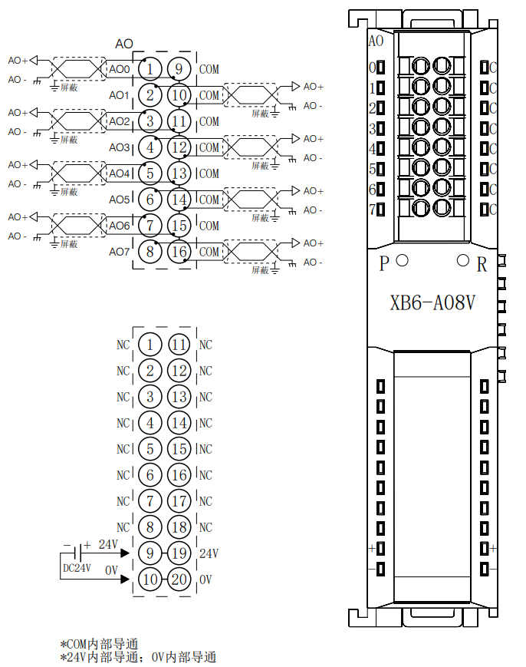
※COM internal conduction
※24V internal conduction；0V internal conduction

XB6-A08I
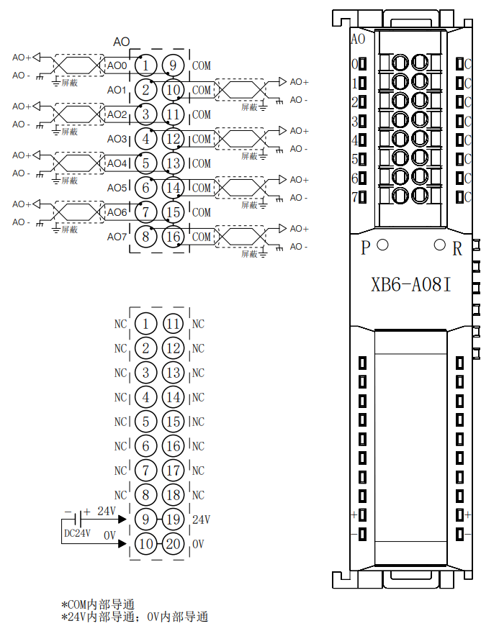
※COM internal conduction
※24V internal conduction；0V internal conduction

XB6-A04V
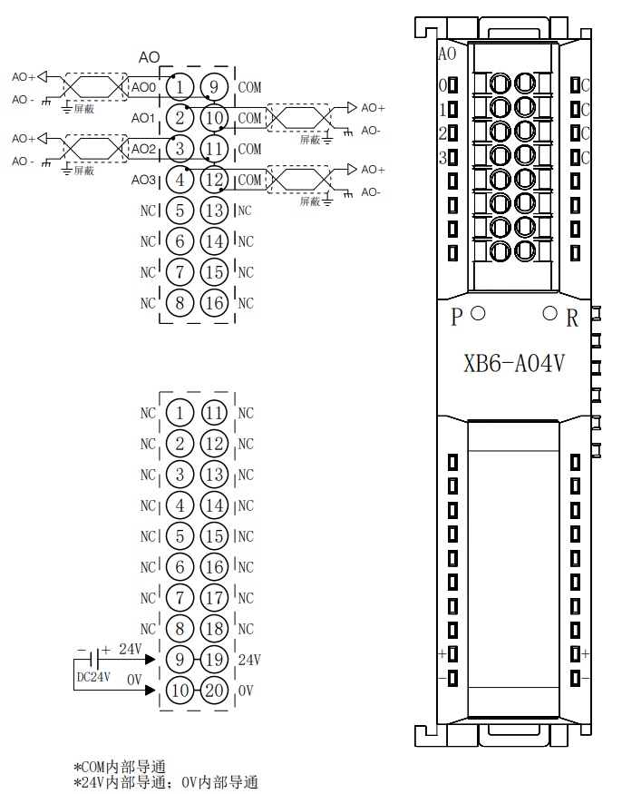
※COM internal conduction
※24V internal conduction；0V internal conduction

XB6-A04I
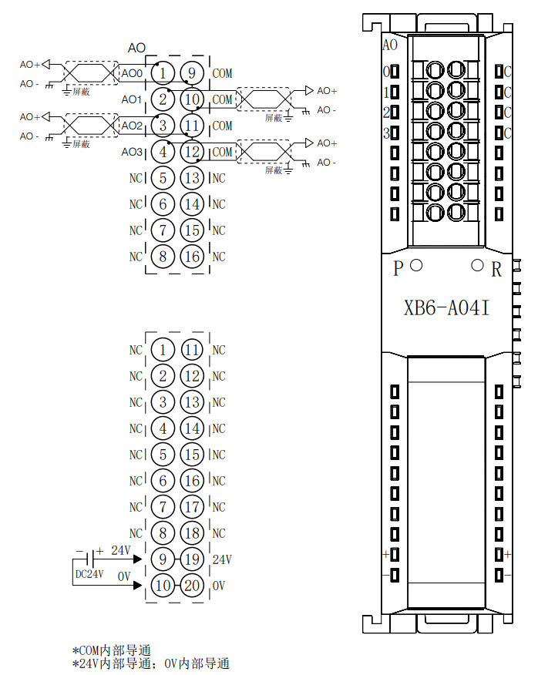
※COM internal conduction
※24V internal conduction；0V internal conduction

XB6-A80TM
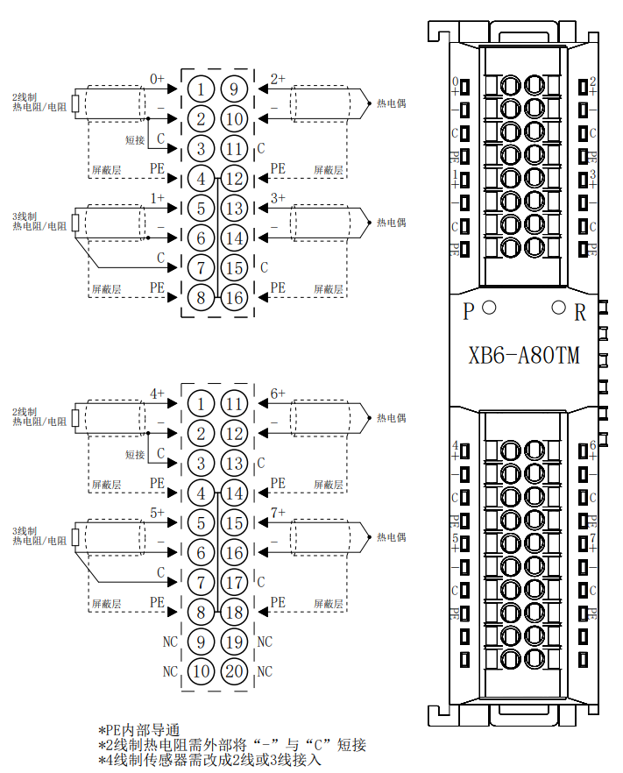
※COM internal conduction
※24V internal conduction；0V internal conduction

XB6-A40TM
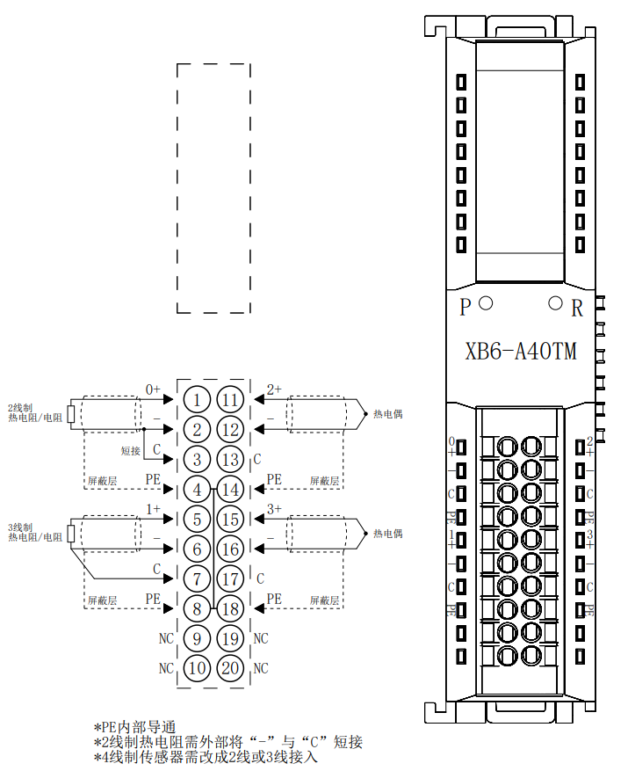
※PE internal conduction
※2-wire thermal resistor needs to short-circuit "-" and "C" externally
※4-wire sensors need to be changed to 2-wire or 3-wire access

Common Expansion Module Wiring Diagram
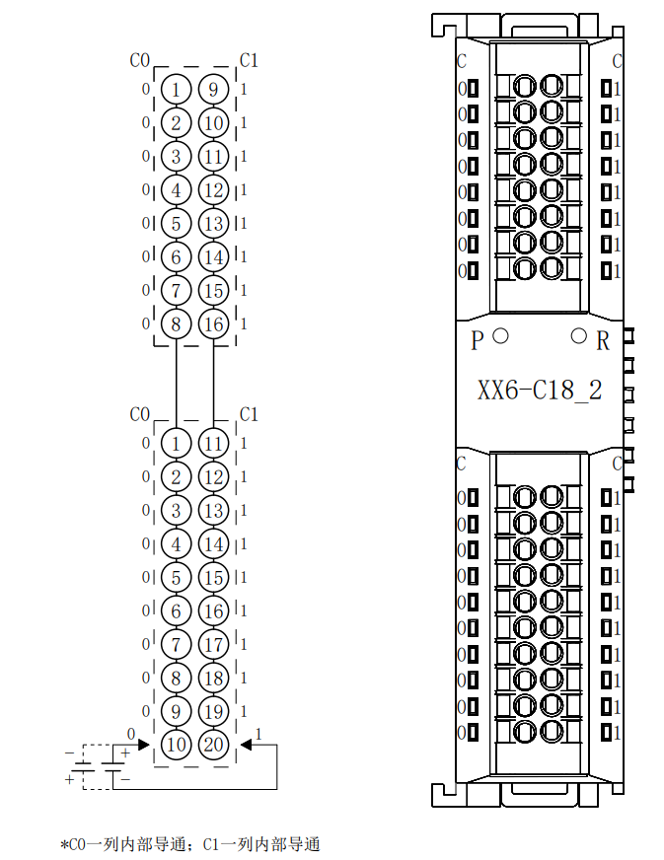
※CO column is internally conductive;
CI column is internally conductive

Operation

Module application
The products are applied using a combination of couplers, I/O modules, and end caps in the following two combinations.
Product combination type I (coupler, I/O module, end cap)
 | Coupler | I/O Modules | End cover
 | 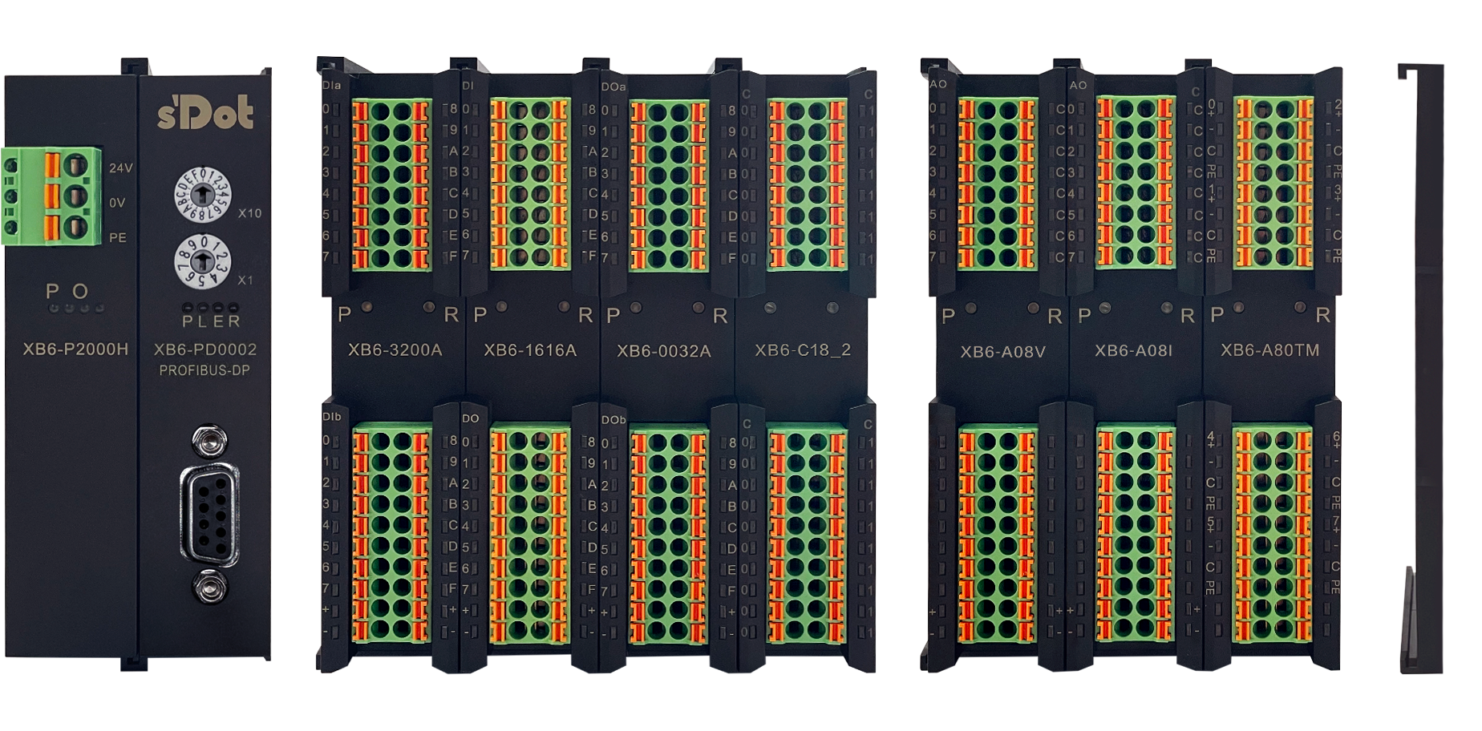

Product combination type II (coupler, I/O module, power supply module, I/O module, end cover)
Coupler I/O Module Power Module I/O Module End cover
Refer to the following principles for the number of I/O module configurations:
- The number of IO modules that can be supported by a coupler is not higher than 32.
- The number of analog modules should not exceed 12, and the number of 8-channel analog inputs
should not exceed 6.

Limitations on the number of power supply and extended power module configurations:
- If the number of I/O modules configured in the system exceeds 10, it is necessary to increase the expansion power module, and the number of I/O modules configured after the expansion power module is ≤ 12.

I/O module parameter configuration function

Digital Input Filtering
Digital input filtering can prevent unexpected rapid changes in program response input signals. Such changes may result from jumping of switch contact or electrical noise. The default value of digital input filtering is currently fixed at 3ms and all clutters within 3ms can be filtered out. Separate channel configuration is not allowed.
The 3ms input filtering time means that a single signal changing from 0 to 1 or from 1 to 0 can only be detected after 3ms has lapsed following such change, while a single high pulse or low pulse shorter than 3ms will not be detected

Analog Filter configuration
● Analog input filtering function
The analog input filtering function can average the data internally after A/D conversion to reduce the
fluctuation effect on input signals due to noise.
Analog inputs are subject to moving average processing based on the specified A/D conversion times.
● Filtering function configuration
Each channel can be configured separately. Configuration range: 1~200, default: 10.
Sampling rate of 8-channel module: 1.25 KHZ/8 channels (800 us/8 channels)
Sampling rate of 4-channel module: 2.5 KHZ/4 channels (400 us/4 channels)

Analog range selection
Analog support range selection function, all channels unified configuration, the specific range see "analog parameters".
See 7.3 Bus Module Configuration Description for parameter configuration methods.

Bus Module Configuration Description

Application in TIA Portal V17 software environment
- Preparations
- Hardware environment
- Module preparation
This description uses the XB6-PD2002ST Module Kit, XB6-1616B, XB6-A04V and end cover as examples.
- A computer installed with TIA Portal V17 software
- PROFIBUS-DP special communication cable (RS485 communication cable)
- A Siemens PLC, this description takes S7-300 CPU315-2 PN/DP 6ES7315-2EH14-0AB0 for example
The IP address of the computer's Ethernet interface needs to be set to ensure that it is on the same network segment as the PLC.
- A switching power supply
- Module installation guide rail and fasteners
- Device Configuration Files
Configuration file access: https://www.solidotech.com/documents/configfile
- Hardware configuration and wiring
Please operate according to "5 Mounting and dismounting" and "6 Wiring".

- Project Creation
- Open TIA Portal V17 software, click "Create New Project", enter the information and click "Create" button, as shown below.
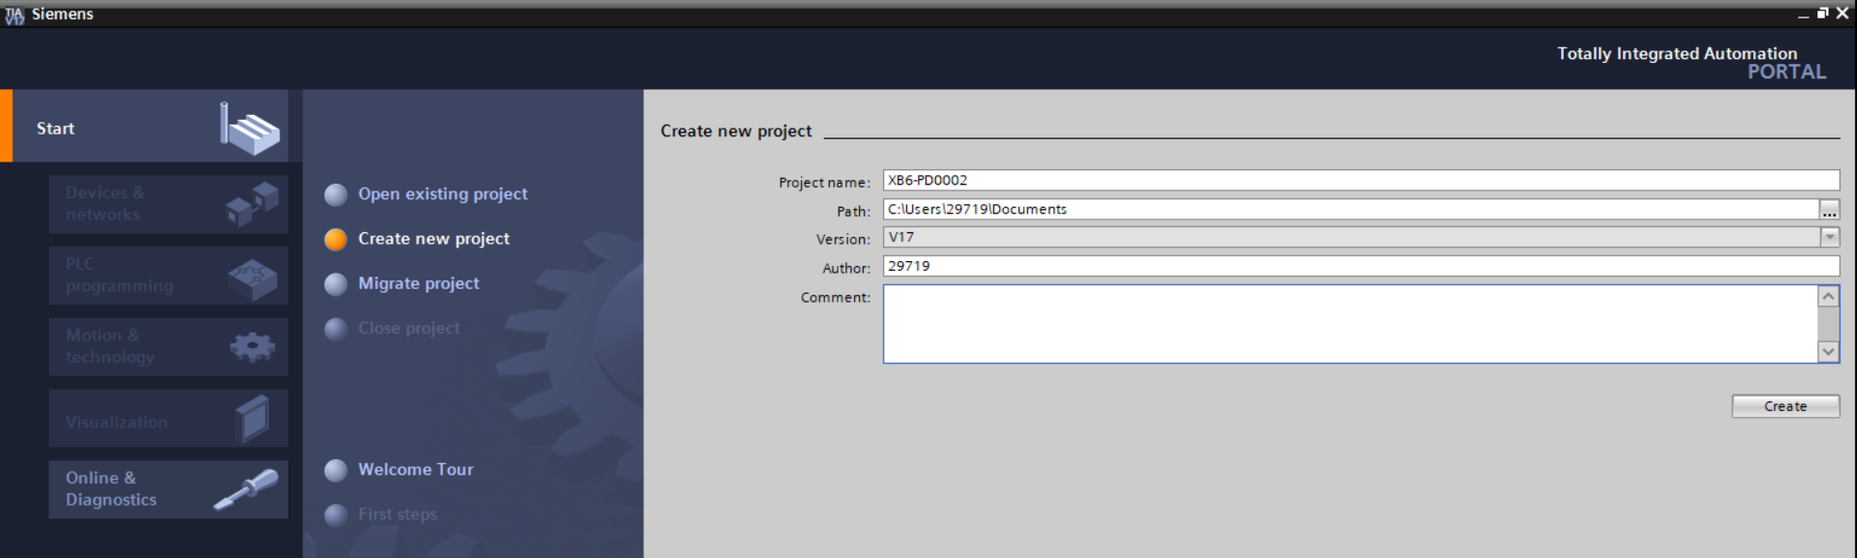
- Project name: Customize, can keep the default.
- Path: The project keeps the path, which can be kept as default.
- Version: Can keep the default.
- AUTHOR: Can keep the default.
- Comment: Customize, can keep the default.

- Adding a PLC controller
- Click “Configure A Device”, as shown in the following figure.
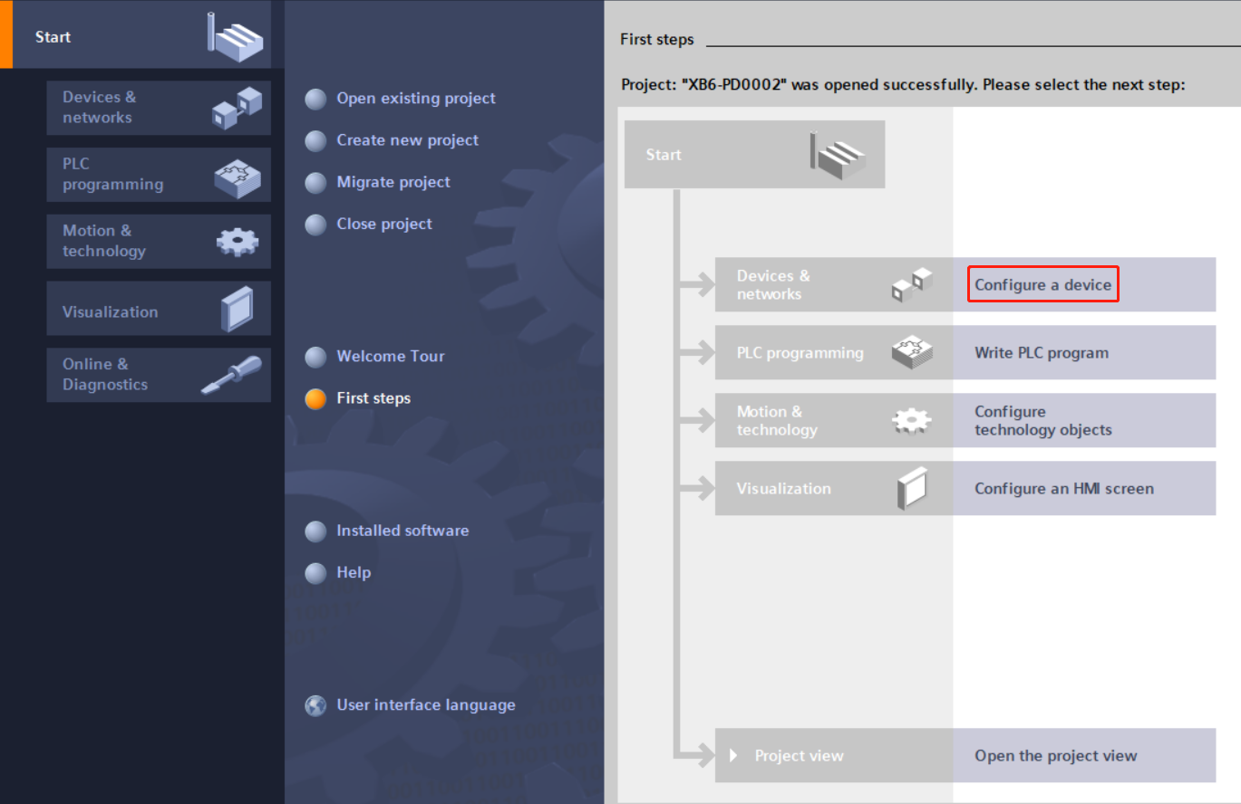

- Click "Add New Device", select the PLC model you are currently using, and click the "Add" , as shown in the following figure. After adding, you can see that the PLC has been added to the device navigation tree.
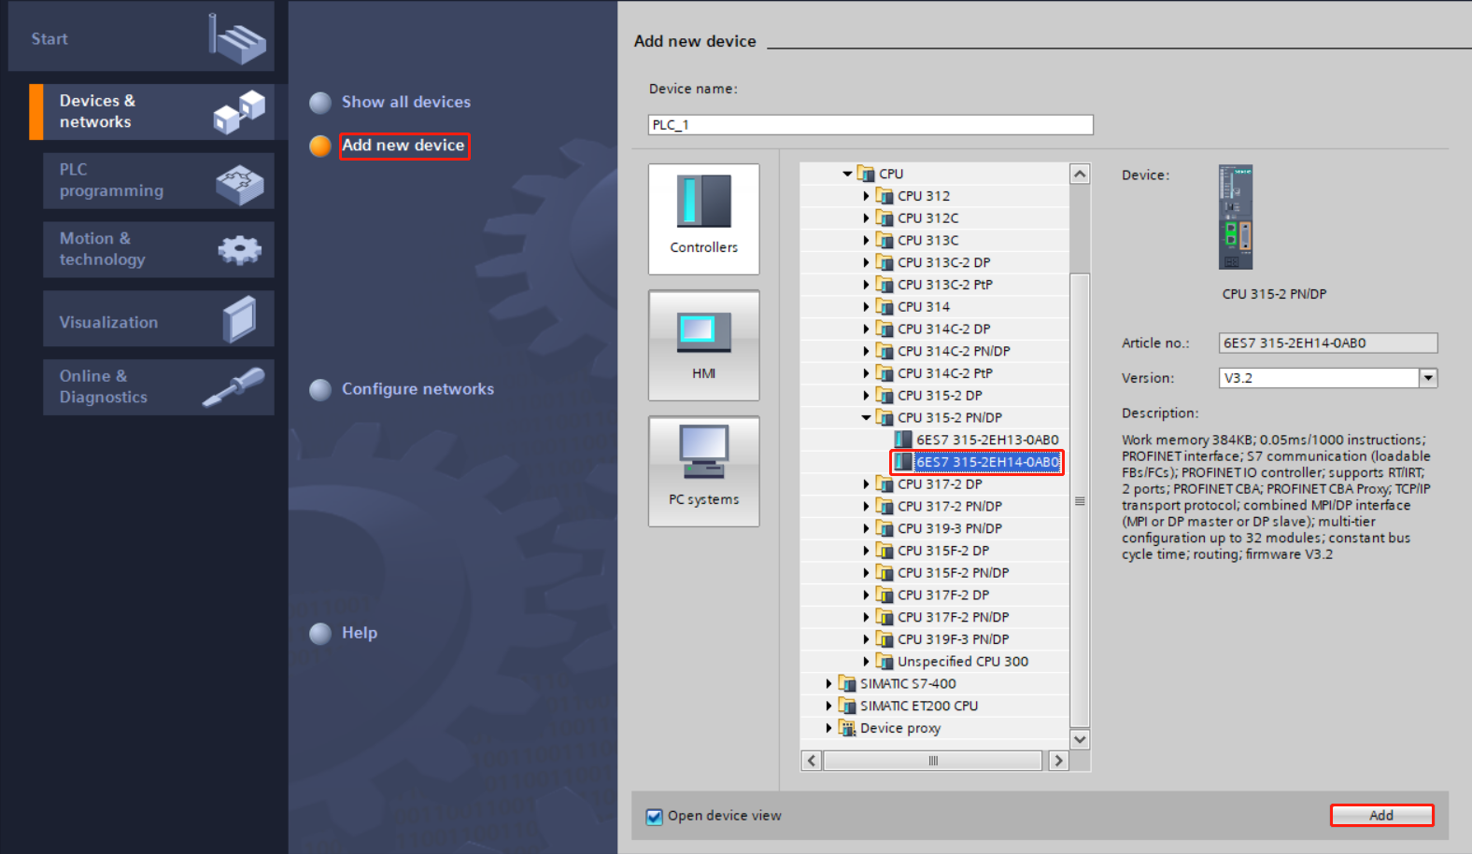

- Adding GSD profile
- In the menu bar, select "Options -> Manage General Station Description File (GSDML) (D)".
- Click “Source Path” to select the file.
- Check if the status of the GSD file you want to add is "Not yet installed", click the "Install" button if it is not installed, or click "Cancel" if it is already installed to skip the installation step.
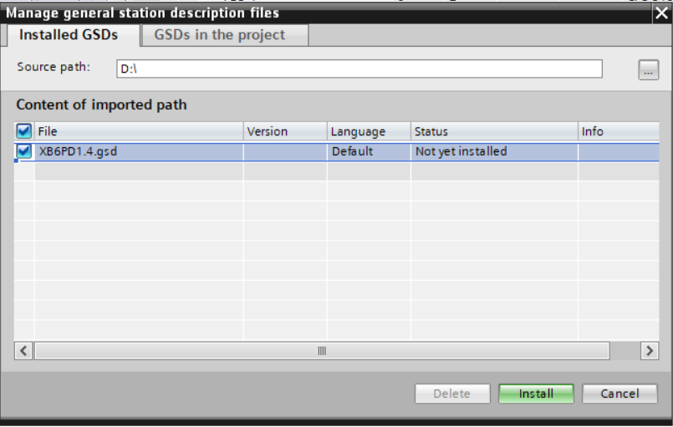

- Adding Slave Devices
- Double-click the left navigation tree "Devices and Networks", and then Click the "Hardware catalog" vertical button on the right side to display the following directory.
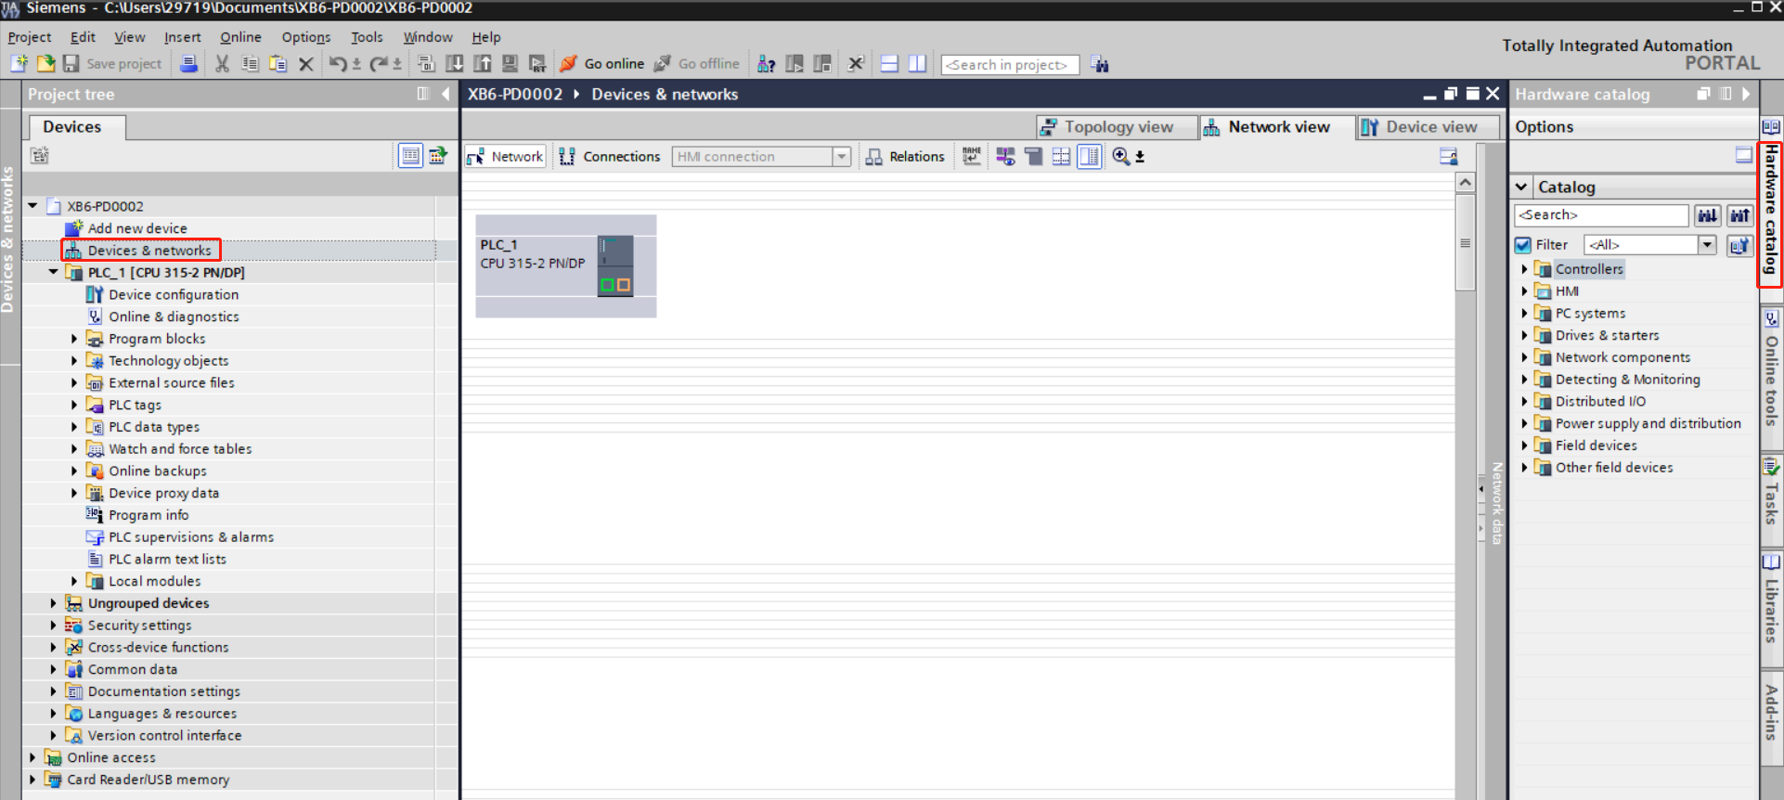

- Enter "XB6-PD2002" in the search box of the hardware directory to search for the coupler. After searching, drag or double click "XB6-PD0002" to the "Network View", as shown in the following figure. 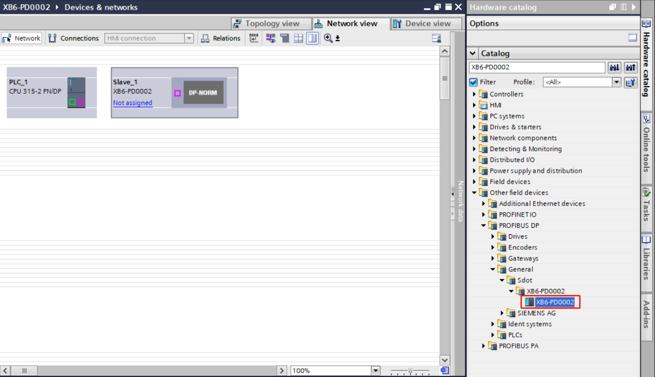

- Click "Unassigned (blue font)" on the slave device and select "PLC_1.MPI/DP Interface_1" as shown below.
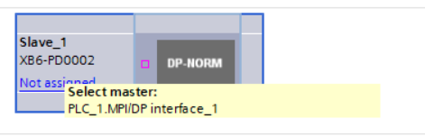
- When the connection is complete, it is shown in the following figure.
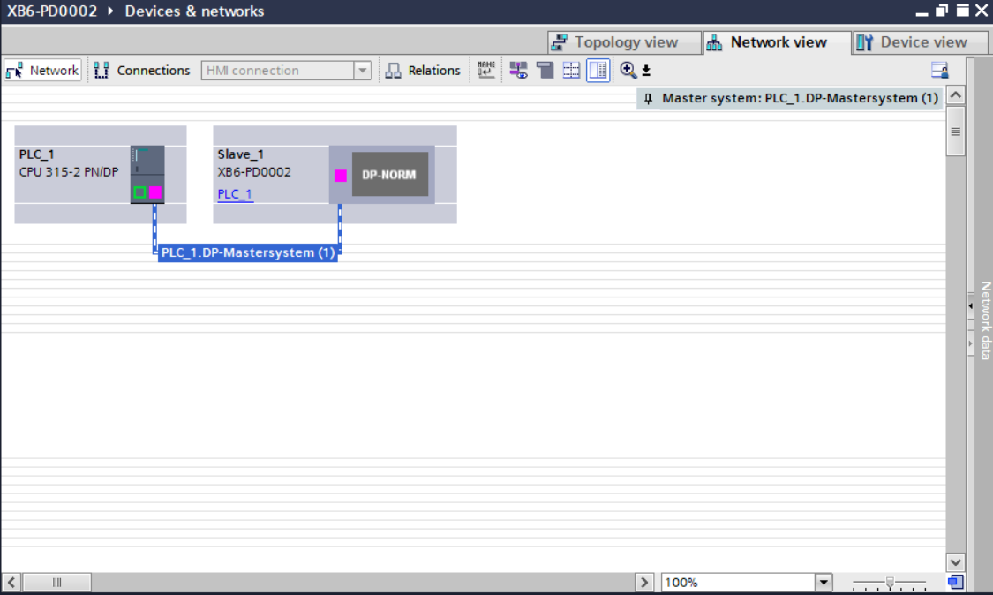

- Click on the device name to rename the device, as shown below.
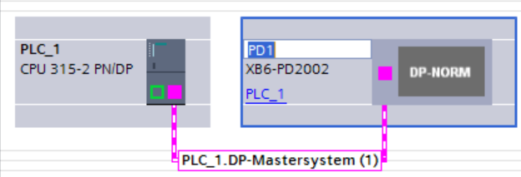

- Right-click on the Coupler View icon section and click “Properties” to see the Properties menu, as shown in the following figure.
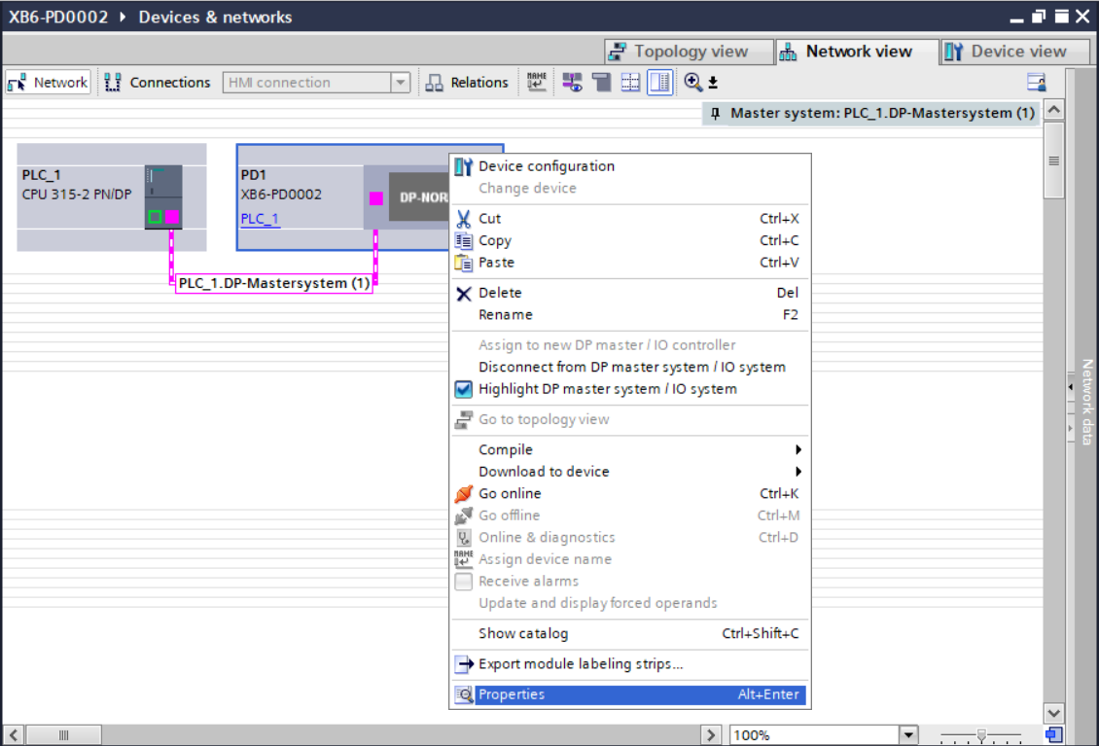

- In "Properties", you can view the coupler's station address and transmission rate and other parameters, you need to set the coupler's dip switches with the same address, as shown in the following figure.
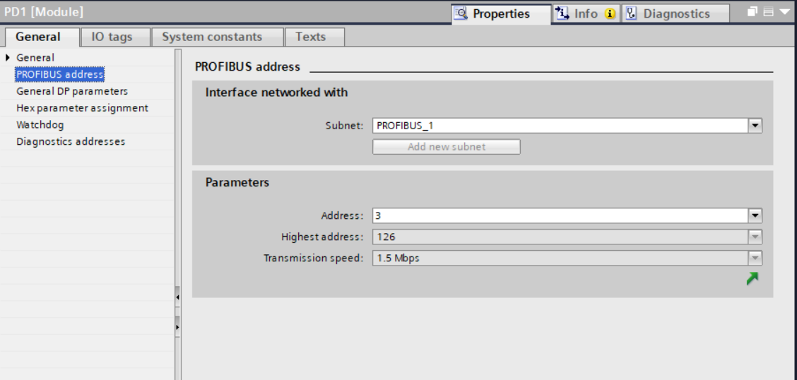

- Click "Device View" to enter the device overview of the coupler, and under the "Modules" directory on the right side, add the I/O modules according to the actual topology (the order must be consistent with the actual topology, otherwise the communication will not be successful), as shown in the following figure.
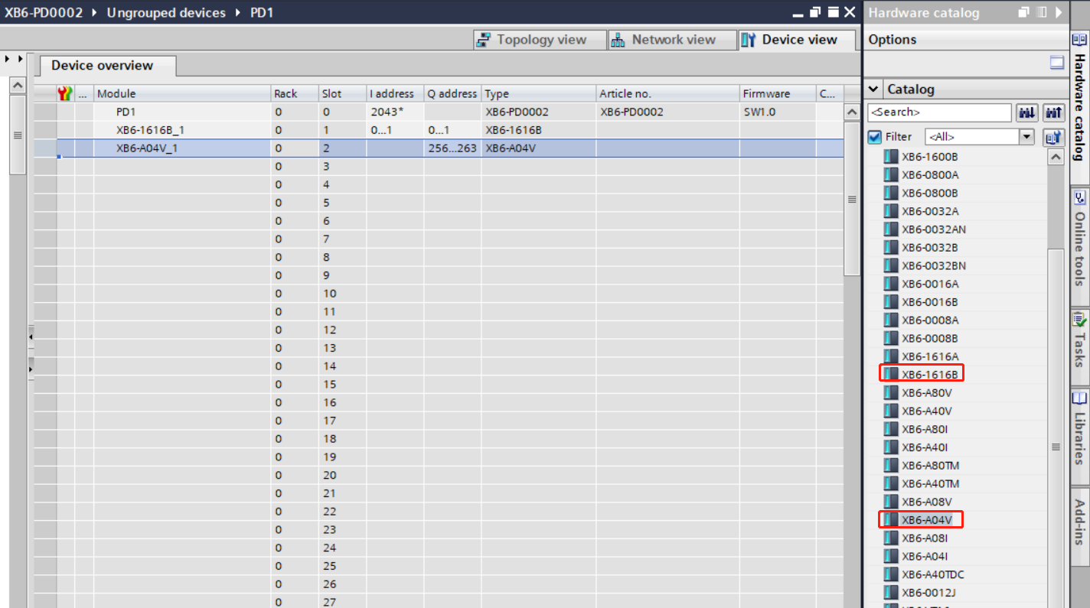
Note: Up to 32 modules can be added. I/O addresses are assigned by the system or can be changed.

- Download Configuration Structure
- After the I/O modules are added, switch to "Network View". In the "Network View", select PLC and click the "Download to Device" button on the toolbar, as shown in the following figure.
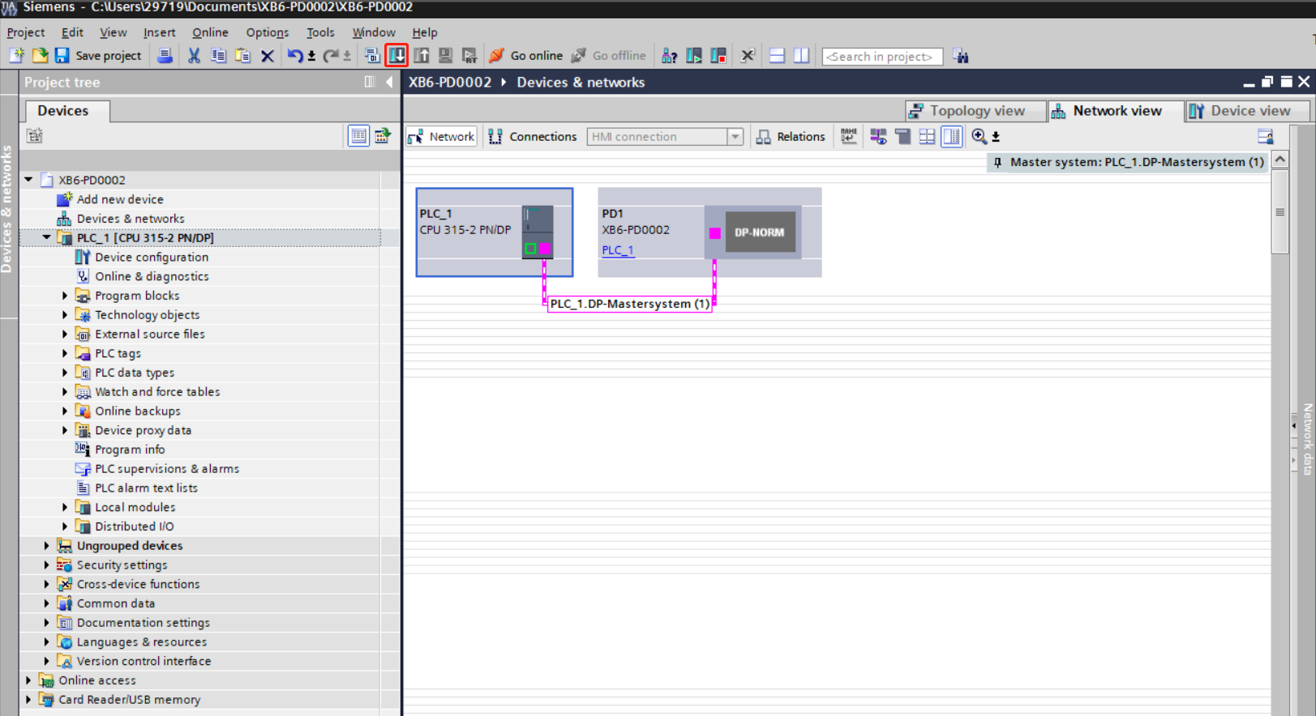
Note: Perform this operation whenever the topology is changed, otherwise the PLC may report an error.

- In the Extension Download to Device window, click the "Start Search" button, and when the search is complete, click the "Download" button, as shown in the following figure.
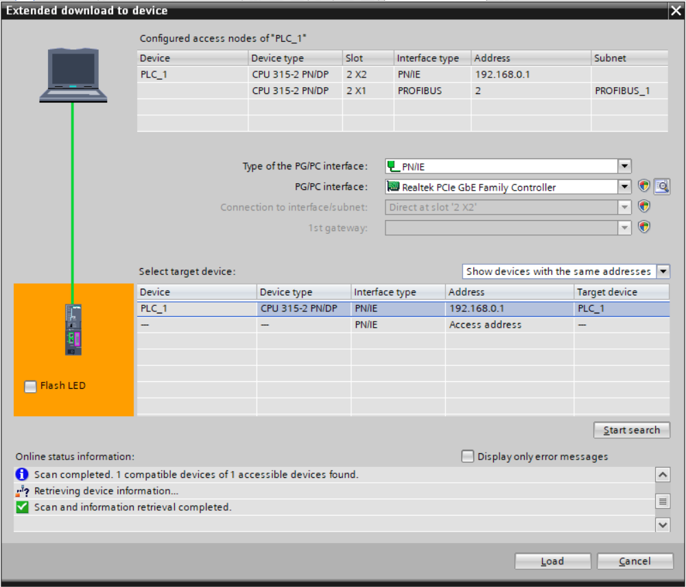
- Go to the download preview page and click the "Load" button as shown below.
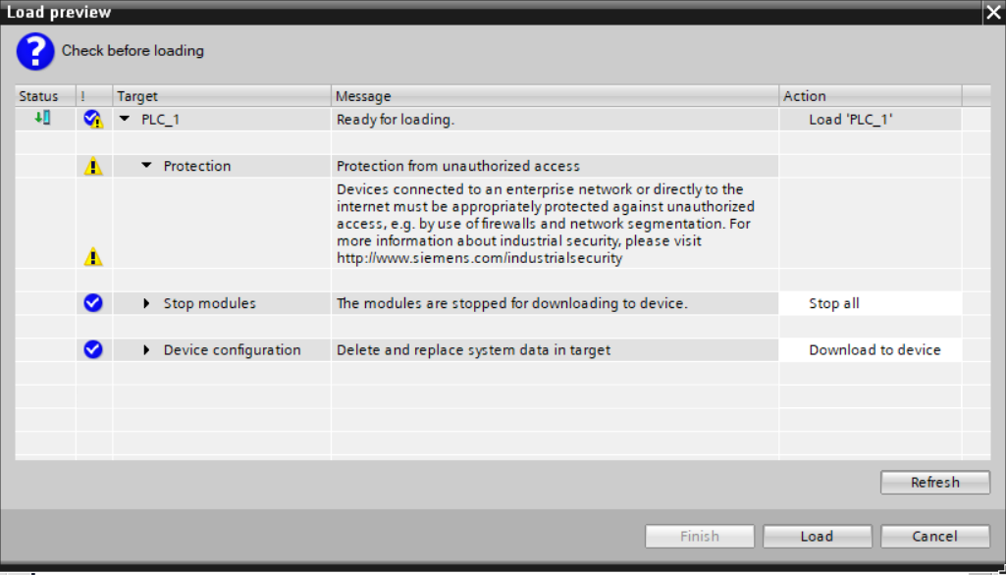

- Go to the download results page and click the "Finish" button, as shown below.
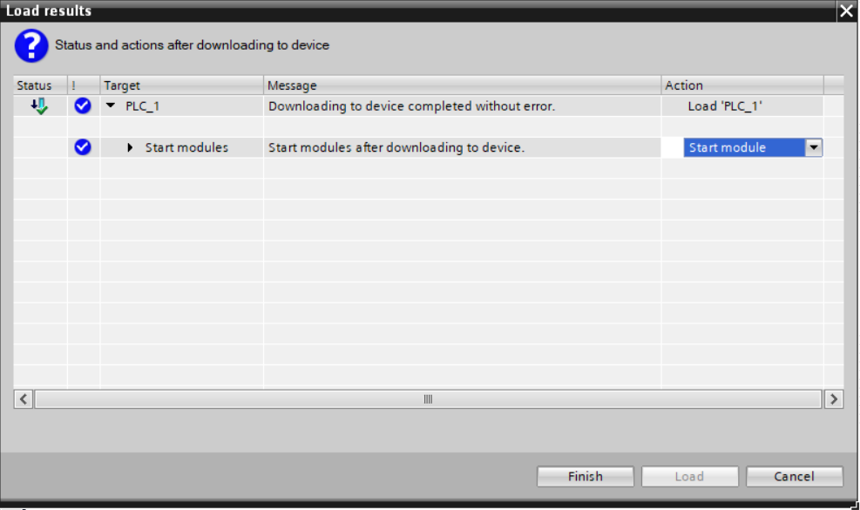
- Power the unit back up.

- communication link
- Click the "Go Online" button on the toolbar, as shown below.
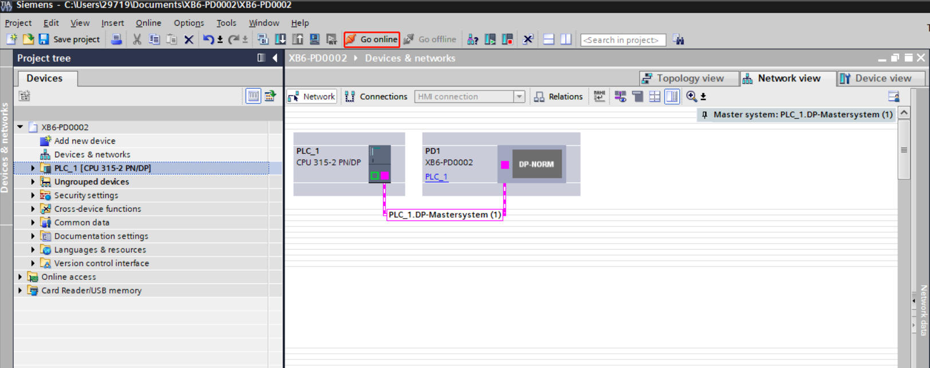

- In the Select Device window, check PLC and click the Go Online button as shown below.
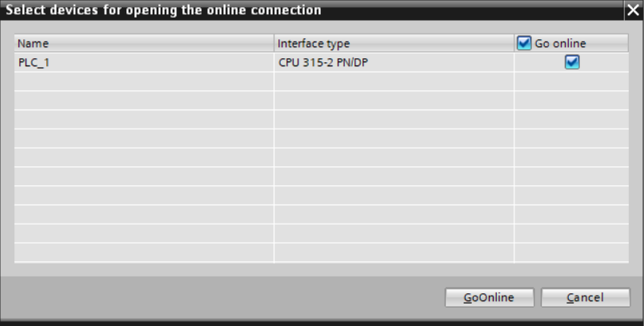

- After successful connection, the left navigation tree and network view are shown below.
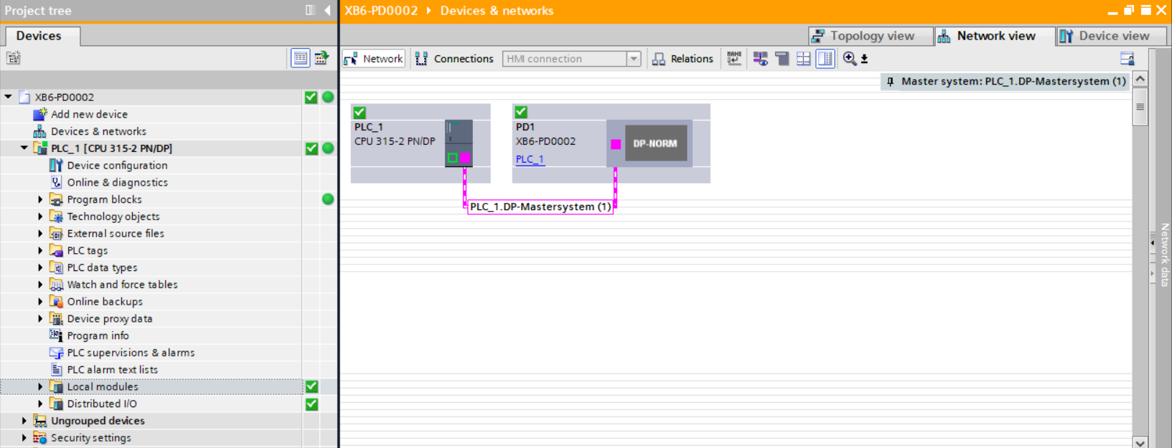

- Check the device indicator
XB6-P2000H: P lamp is always on in green.
XB6-PD0002: P lamp green is always on, L lamp is always on, B lamp is not on, R lamp is always on.
Modules XB6-1616B and XB6-A04V: P lamp is always on, R lamp is always on.

- Parameter setting
- Turn the device to offline state, open the "Network View", select the coupler module, right-click "Properties", you can view and set the coupler parameters, address and transmission rate, etc., as shown in the following figure.
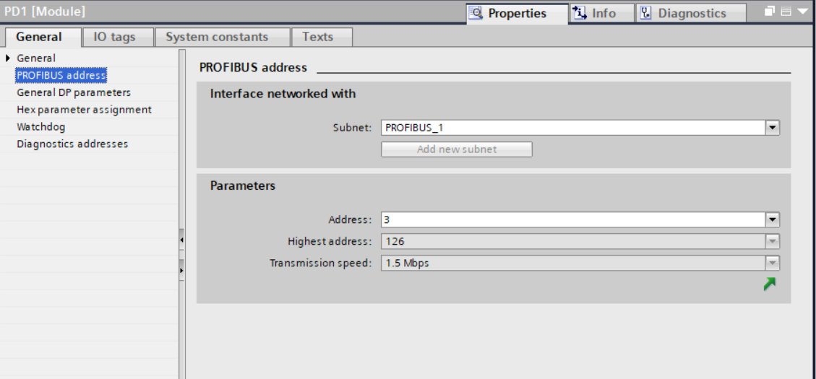

- Click "Device View" to enter the device overview page, right-click the XB6-1616B module, click the "Properties" button, you can view and set the parameters of the module, such as filter parameters, as shown in the following figure.
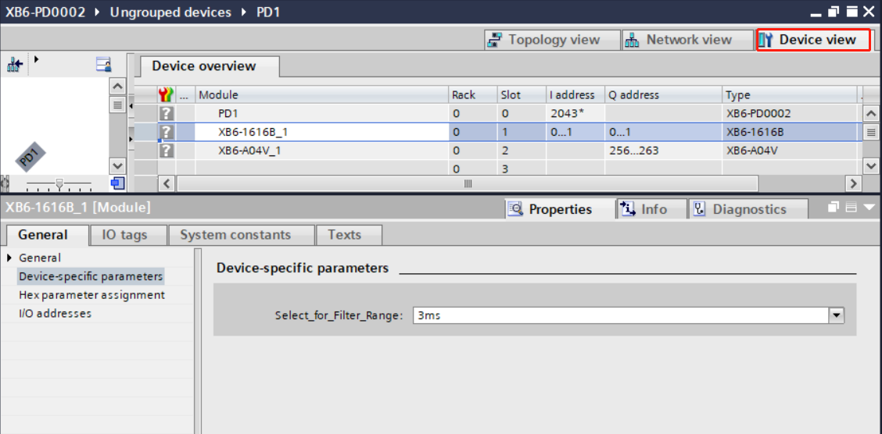

- Right-click on the XB6-A04V module and click the "Properties" button to view and set the parameters of the module, such as setting the analog range, as shown in the figure below.
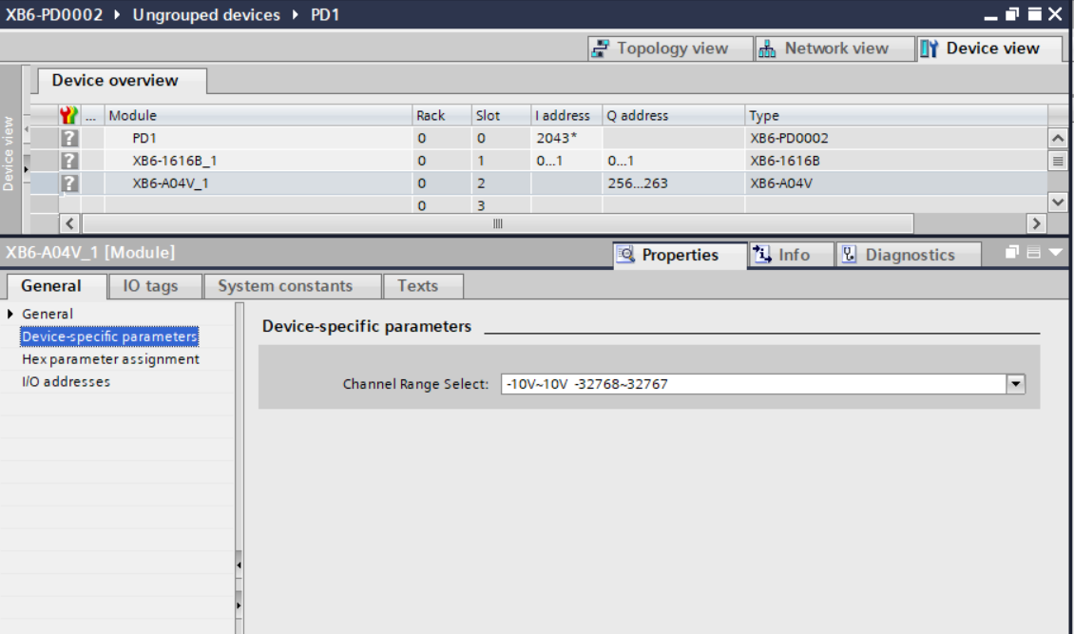

- Parameters can be configured according to the actual use of the need to configure, after the configuration is complete, re-download the program to the PLC, PLC and the module need to be re-powered.

- Functional verification
- Expand the left side of the project navigation, select "Monitor and Force Meter", as shown in the following figure.
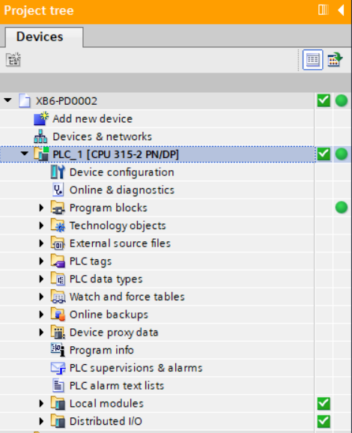

- Double-click "Add New Monitor Table", the system adds a new monitor table, as shown in the following figure.
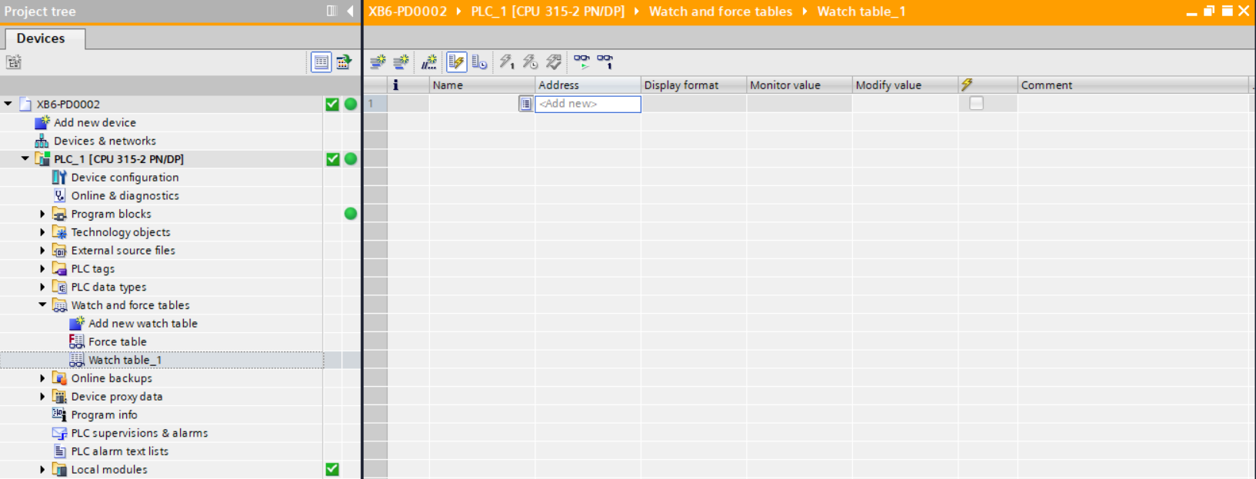

- Click the button.

- Open the Device View and check the channel Q address (channel address of the output signal) or I address (channel address of the input signal) of the module in the device overview.
For example, you can see the "Q address" and "I address" of XB6-1616B and XB6-A04V modules as shown in the following figure.
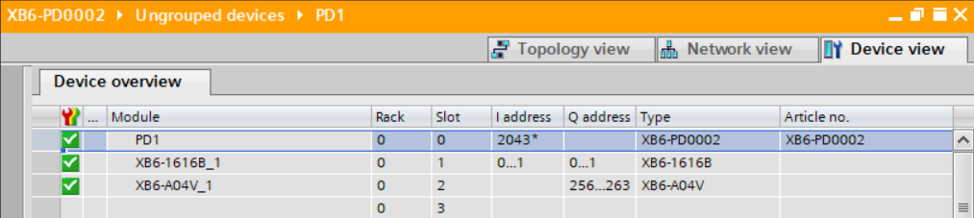

- Fill in the address cell of the monitoring table with the addresses of the input and output channels, such as "QB0... QB0...QB1", "IB0... QB0...QB1", "IB0...IB1", "QB256... QB263", press "Enter", as shown below.
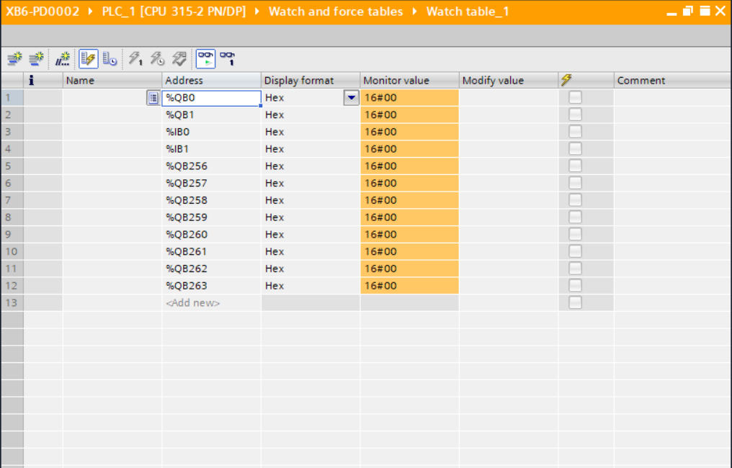

- Enter the value in the "Modified Value" cell, click the button to write, the modified value of "QB0" from "0" to "1 The modified value of "QB0" is written from "0" to "1", and you can see the data in the QB0 address monitoring value, and the channel indicator is always on at the same time.
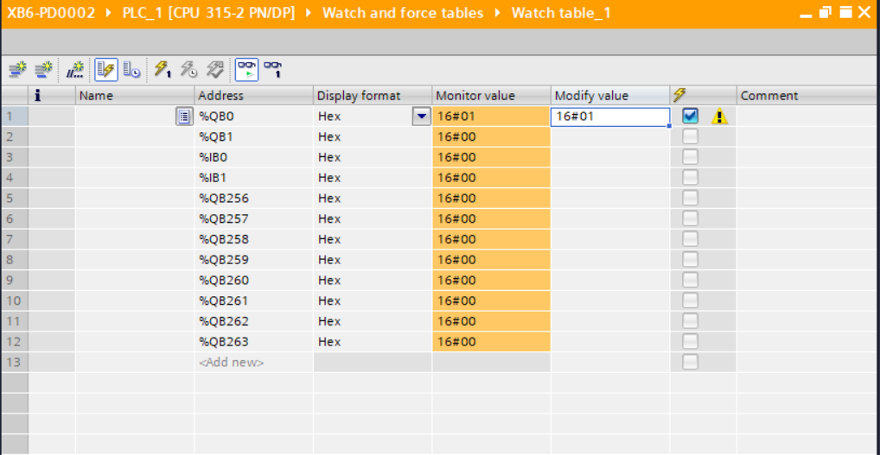

- In the monitoring table, the IB address monitors the input channels of the module.

